Dhaka Water Supply and Sanitation Project

Environmental Management Framework

Dhaka Water & Sanitation Authority
Government of Bangladesh
July 2008

Final Report - EMF
Table of Contents

1 Introduction 1
1.1 Project Authorization 1
1.2 Objective of this Report 1
1.3 The Consultants 1
1.4 Mobilization and Setting up of Office 1
1.5 Background of the Project 2
1.5.1 General 2
1.5.2 Objectives of the Project 2
1.5.3 Scope of Services of the Project 4
1.5.4 Scope of Services of the Sub-Projects 5
1.5.5 Overview and Present Status of Different Sub-Projects 9
2 User’s Guide 12
2.1 Purpose of this Document 12
2.2 EMF Structure and Contents 12
2.3 How to use the Document 13
2.4 Beneficiaries of the Document 14
3 Overview of DWASA 15
3.1 Introduction 15
3.2 Overview of DWASA 16
3.2.1 Organogram 16
3.2.2 DWASA Environmental Cell 17
3.2.3 DWASA Laboratory 19
3.2.4 Capacity Building 20
4 Environmental Policies, Rules & Regulations related to EMF 21
4.1 Environmental Laws, Regulations and Guidelines 21
4.2 Overview of Environmental Policies, Rules and Regulations related to EMF 21
4.2.1 National Policies 22
4.2.2 International Policies 24
4.2.3 Overview of the International EA Guidelines 24
4.3 Study of Existing Environmental and Social Condition 26
4.3.1 Environmental Condition 26
4.3.2 Social Condition 27
4.3.3 Existing Sewage Condition 27
4.3.4 Existing Drainage System 28
4.3.5 Environmental Assessment Process for the Sub-Projects 29
4.3.6 Relationship between EIA and Feasibility Study 29
4.3.7 Relationship between EIA and Detailed Design 29
4.3.8 Relationship between EIA and Construction and Implementation 29
4.3.9 Relationship between EIA and O&M 30
4.4 Environmental Assessment Guidelines 31
4.4.1 Application for Environmental Clearance – E3 (Green) Category 31
4.4.2 Application for Environmental Clearance – E2 (Amber B & A) Category 31
4.4.3 Application for Environmental Clearance – E1 (Red) Category 31
4.4.4 Necessity for EIA 32
4.4.5 General Procedure for EIA 32
4.4.6 Environmental Clearance 33
4.5 Environmental Impacts and Mitigation 34
4.6 Magnitudes of Impacts as per E1, E2 & E3 Classifications 35
5 Environmental Assessment and Management Tools 36
5.1 Introduction 36
5.2 Strategic Environmental Assessment 36
5.3 Environmental Impact Assessment 39
5.4 Environmental Management Plan (EMP) 41
5.5 Environmental Assessment and Management Tools 41
5.6 Environmental Monitoring Mechanism 44
5.6.1 EMP and Monitoring 44
5.7 Risk Assessment 47
5.7.1 Human Health Risk Assessment 48
5.7.2 Ecological Risk Assessment 48
6 Gap Analysis 50
6.1 Introduction 50
6.2 EMF to cover Overall Activities of DWASA 50
6.3 Legal Provisions 50
6.4 Institutional Accountability 52
6.5 Capacity and Training 53
6.6 Resource Constraints 53
6.7 Technical Issues 54
6.8 Monitoring, Compliance and Awareness 54
7 Checklist and Screening of Sub-Projects &/or new Projects 56
7.1 Development and Screening of Sub-Projects 56
7.2 Adaptation of Checklists 62
7.3 Methodology for Screening of Projects 63
7.4 Consultation with Prospective Stakeholders 64
8 The Environmental Management Framework 65
8.1 Introduction 65
8.2 Vision of EMF 65
8.3 Aims and Objectives of EMF 65
8.4 Purpose of EMF 66
8.5 Outlining EMF with DWASA 66
8.6 Identification of a Broad Goal 68
8.7 Policy Development 68
8.8 Implementation of Policy 69
8.9 Monitoring and Review 69
8.10 Undertaking Development Projects 70
8.11 Roles and responsibilities of EMF Process 70
8.12 Revision of EMF 71
9 Conclusions and Recommendations 72

LIST OF TABLES
Table 1: Status of different Packages under PPF Study Projects 10
Table 2 : Sanctioned Manpower of existing Environmental cell Circle, DWASA 18
Table 3: Relevant laws and regulation on water supply and sanitation project 22
Table 4 : Main Components of DS & Associated Works 34
Table 5: Delineate E1, E2 and E3 with DOE and World Bank context: 35
Table 6 : Comparison between EIA and SEA 37
Table 7 : Positive and Negative aspects of Environmental Assessment 41
Table 8 : Environmental Issues and Relevant Laws and Regulations need revision 51
Table 9 : Environmental Issues and Actions for better Institutional Accountability 52
Table 10 : Quality Assurance and Quality Control in Analytical Procedures 55
Table 11 : Blank Checklist for Environmental Parameters for Project Classification 57
Table 12 : Summary Assumptions of the Checklist Form 62
Table 13 : Matrix showing the classification of the Sub-projects 62
Table 14 : Environmental Classifications 64
Table 15 : Monitoring Review Schedule 70

LIST OF FIGURES
Figure 1: Map showing all MODS Zones of DWASA and Project Boundary 3
Figure 2 : New Organogram (Top Management Part only) 16
Figure 3 : Project Planning, Feasibility Study, Implementation and EIA Process 30
Figure 4 : Steps Leading to Grant of Environmental Clearance 33
Figure 5 : Generic SEA Process Diagram 38
Figure 6 : EIA in Project Lifecycle of DWASA 40
Figure 7 : Steps of Environmental Assessment and Management Tools 43
Figure 8 : Environmental Risk Assessment Process 49
Figure 9 : EMF Structural Diagram 67

List of Annexure

Annexure 1 | Adaptation of Checklist for DS 1A to DS 10
Annexure 2 | Project Implementation Manual
Annexure 3 | WSS Manual to Low Income Communities
List of Acronyms and Abbreviations

ADB | Asian Development Bank
BBS | Bangladesh Bureau of Statistics
BETS | BETS Consulting Services Ltd. (Previously - Bangladesh Engineering and Technological Services Ltd.)
BUET | Bangladesh University of Engineering & Technology
BOD | Bio-Chemical Oxygen Demand
BWDB | Bangladesh Water Development Board
COD | Chemical Oxygen Demand
CEC | Commission of European Communities
CETP | Central Effluent Treatment Plant
CBO | Community Based Organization
CEIA | Complete Environmental Impact Assessment
CUP | Coalition for Urban Poor
CUS | Centre for Urban Studies
DMDP | Dhaka Metropolitan Development Plan
DPP | Development Project Proforma
DAP | Detailed Area Plan
DOE | Department of Environment
DWASA | Dhaka Water Supply and Sewerage Authority
DPHE | Department of Public Health Engineering
DCC | Dhaka City Corporation
DOI | Department of Industries
DFID | Dhaka Integrated Flood Protection
DS | Dhaka Sanitation
EA | Environmental Assessment/ Appraisal
ES | Environmental Screening
EOI | Expression of Interest
EHP | Environmental Health Project
ERA | Environmental Risk Assessment
ESU | Environment and Social Unit
EMS | Environmental Management System
EIMP | Environmental Impact Management Plan
EQS | Environmental Quality Standards
EAC | Environmental Assessment Complete/ Clearance
ECC | Environmental Clearance Certificate
ETP | Effluent Treatment Plant
EAP | Environmental Action Plan
EIA | Environmental Impact Assessment
EMF | Environmental Management Framework
EMP | Environmental Management Plan
FS | Feasibility Study
FAP | Flood Action Plan
FGD | Focus Group Discussion
FPCO | Flood Plan Co-ordination Organization
GOB | Government of the People’s Republic of Bangladesh
HHRA | Human Health Risk Assessment
IEMF | Integrated Environmental Management Framework
IWM | Institute of Water Modelling
IDA | International Development Association
ISO | International Organization of Standardization
ISC | Inter Ministerial Steering Committee
IEE | Initial Environmental Examination
JIBIC | Japan Bank for International Co-operation
LGED | Local Government Engineering Department
MDG | Millennium Development Goal
MODS | Maintenance, Operation, Distribution & Services
MOEF | Ministry of Environment and Forestry
NOC | No objection Certificate
NGO | Non Government Organization
NTU | Nephelometric Turbidity Unit
NWP | National Water Policy
NWMP | National Water Management Plan
O&M | Operation and Maintenance
PD | Project Director
PIU | Project Implementation Unit
PIM | Project Implementation Manual
PPF | Project Preparatory Fund
PAP | Project Affected People
PVC | Poly Vinyl Chloride
PSC | Project Steering Committee
PPMS | Project Performance Management System
RTIP | Road Transport Improvement Project
RFP | Request for Proposal
RPF | Resettlement Policy Framework
RAP | Resettlement Action Plan
REA | Rapid Environmental Assessment
RAJUK | Rajdhani Unnayan Katripakhkha
RCC | Reinforced Cement Concrete
SEI | Significant Environmental Impact
SEA | Strategic Environmental Assessment
SIA | Social Impact Assessment
SDM | Standard Directive Measures
SEMP | Strategic Environmental Management Plan
SEIA | Summary of Environmental Impact Assessment
SIEE | Summary of Initial Environmental Examination
SWTP | Surface Water Treatment Plant
STIFPP | Secondary Town Infrastructure Flood Protection Project
STP | Sewage Treatment Plant
TOR | Terms of Reference
TOC | Table of Contents
TDS | Total Dissolve Solid
UN | United Nations
USEPA | United State Environmental Protection Agency
uPVC | Un-plasticised Poly Vinyl Chloride
WB | World Bank
WSS | Water Supply and Sanitation
WARPO | Water Resource Planing Organization
WTP | Water Treatment Plant
WHO | World Health Organization

Comments / Suggestions of Dhaka WASA and Workshop

Sl # | Comments of DWASA | Action Taken by the Consultant
Comments/Suggestions of DWASA Committee
1 | The Key functions of DWASA described in chapter – 3 do not reflect the present situation. Recently developed DWASA organogram has not been considered in the report. The committee suggests to update the description of chapter – 3 incorporating the newly developed DWASA organogram, | DWASA Organogram approved by Govt. in November, 2007 has been incorporated in Chapter – 3.
2 | Chapter – 4 : As per ToR “Art – 1.5.3.3) the consultant should summarize its view highlighting weakness of the existing policy & legal framework with the National Policy and World Bank. But it is not given in the report. This should be included in chapter - 4 of the report. | Gap Analysis has been incorporated in Chapter – 6, which highlighted the weaknesses.
3 | As per ToR (Art 1.5.3.6) the consultant would present EMF in two parts (i) Generic Section and (ii) Specific Section, but this is not considered in the report. The committee suggests to incorporate a write up in this regard in the report. | Chapter – 1 to 3 are the Generic Section and the rest are Specific Sections.
4 | The conclusions and recommendation made in chapter – 8 are very concise, which is a little bit difficult to understand. The committee proposes to make the recommendations elaborate and easy to understand. | As per suggestions of DWASA, Conclusion and Recommendation has been re-written in Chapter - 9
5 | The manual prepared in bangla annexed – 2 contain some photographs. The committee suggests to make these photographs more attractive and slogans as poster forms may be kept in the manual. | Printed in colour, now looks better.
6 | The committee suggests to keep an Executive Summary in the report. | Executive Summary has been incorporated.
7 | The committee is informed that a workshop will be held on this Draft Final Report within short time. The committee urges to update this report incorporating the findings of the workshop. | The findings of the Workshop have been incorporated.
Decisions/Comments of the Workshop held on 20th September’07
A | This EMF would be confined under five sub-projects of Dhaka WASA. There should be one general EMF guideline for overall activities of Dhaka WASA. | No Action to be taken by the present Consultant
B | Classification of Impact should be revised considering present situation of Dhaka WASA and study Project should not be classified as E1. | Classifications have done both for the Study and Implementations.
C | One chapter Gap for Analysis to be included in the EMF report. | Gap Analysis has been included in Chapter – 6.

Executive Summary

- The Project

The Government of the People’s Republic of Bangladesh (GOB) has received an advance credit for preparation of the proposed Dhaka and Chittagong Sewerage and Drainage Sector Project from the International Development Association (IDA : PPF Study Project - Credit # Q 4780) and part of the credit shall be used for the improvement of Sewerage and Drainage Sector of Dhaka City in different packages (DS 1A to DS 10) under Dhaka Water Supply and Sewerage Authority (DWASA). Consultancy Services for the Environmental Management Framework (Package DS – 5) is one of the packages.

  - Objectives and Scope of Services

The Objectives of the assignment are summarized as under :

  - To provide guidance for preparation of the Environmental Management Framework (EMF),
  - To provide mitigation plans, compliance with the National and World Bank environmental safeguard policies,
  - To deal with the adverse & negative environmental impacts, during execution of the different sub-projects undertaken by DWASA,
  - To improve the quality of the project design and its overall viability and sustainability.

  - The scope of Services are summarized as under :

- To develop EMF for different sub-projects,
- The EMF is intended mainly for use to assess the sub-projects those come on board,
- The EMF needs to be designed and tested before the project become effective, to be implemented by DWASA
- The EMF includes –

  - Guidance for environmental screening of sub-projects,
  - Guidance for the environmental assessments to be done for the sub-projects
  - Formulation of environmental management, mitigation & monitoring plans,
  - Policy and legal framework, and institutional arrangements for implementation of EMF
  - To prepare “Implementation Manual” and “WSS Manual” in Bangla for Low Income Communities
  - Assessment for the classification of the sub-projects under environmental categories E1, E2 & E3.

  - The Scope of Works of different Sub-Packages are summarized as under

- Wastewater Management (DS-1) postponed and new project undertaken for Preparation of Master Plan for Waste Water Management (DS -1A),
- Wastewater Studies (DS-2),
- Dhaka Storm Water Drainage including two Storm Water Pump Stations at Rampura and Kamlapur (DS-3),
- Resettlement Action Plan (DS-4),
- Environmental Management Framework (DS-5),
- Dhaka WASA Performance Improvement Programme (DS-6),
- WSS Program to Low-Income Communities (DS7).
- Tracer Study (DS - 8)
- Social Safeguard Issues (DS - 9)
- Canal Development for Storm Water Drainage (DS – 10)
- Master Plan for Wastewater Management (DS – 1A), postponing DS – 1.

- User’s Guide

This chapter describes (a) purpose of the document (b) Chapter-wise contents, (c) How to use the Document, and (d) Beneficiaries of the document.

- Overview of DWASA

- DWASA is a public service institution, operating on Commercial basis.
- New Organogram of DWASA has been approved by the Government in November, 2007, relevant part of which has been shown in the report.
- It is mandated to cater to the water supply, sewerage and primary storm water drainage services to the dwellers of Dhaka Metropolitan City and Narayanganj town through 7(seven) MODS Zones.
- Present Services Facilities

  - Water Supply Services
    - Water Pipelines = 2,534 Km
    - # of SWTP = 3
    - # of DTW = 465
    - # of OHT = 38

  - Sewerage Services
    - Sewer Lines = 881 Km
    - # of STP = 1 (serving 20% of the present population)
    - # of SLS = 29

  - Drainage Services
    - Conduit Drains = 230 Km
    - Open Khal = 65 Km
    - Box Culvert = 8 Km

- Environmental Policies, Rules & Regulations related to EMF

This chapter highlights the environmental Laws, Rules & Regulations which are described precisely in sections 4.1 to 4.2 including the National Policies, International Policies, Overview of the International EA Guidelines, etc.

The existing Environmental and Social Conditions are described in section 4.3 including environmental condition, social condition, existing sewage and drainage condition, environmental assessment process for the sub-projects, relationship between EIA and Feasibility Study, Relationship between EIA and Detailed Design, Relationship between EIA and Construction & Implementation, Relationship between EIA & O&M, etc. and all these relationships are graphically represented in Figure # 3 : Project Planning, Feasibility Study, Implementation and EIA Process.

The Environmental Assessment Guidelines has been described in section 4.4, which includes Application for Environmental Clearances for E3, E2 & E1 Categories, Necessity for EIA, General Procedure for EIA and Environmental Clearance and all these activities are shown graphically vide Figure # 4 : Steps Leading to Grant of Environmental Clearance.

Environmental Impacts and Mitigation has been described in section 4.5 and the major components of DS 1A to DS 10 and associated works has been shown in Table # 3 and the magnitude of Environmental Impacts as classified by DoE (Red, Amber B&A, Green), World Bank (A, B C) and DWASA (E1, E2, E3) are shown in Table # 4.

- Environmental Assessment and Management tools

In this chapter the Strategic Environmental Assessment (SEA) has been described in section 5.1 to 5.2, which includes the Comparison between EIA and SEA, which has been shown in Table # 5 and a Generic SEA process diagram is reflected in Figure # 5. Environmental Impact Assessment (EIA), Environmental Management Plan (EMP), Environmental Assessment and Management Tools, Environmental Monitoring Mechanism and EMP & Monitoring, etc. have been described in sections 5.3 to 5.6. EIA in Project Cycle of DWASA has been shown in Figure 6 and Steps of Environmental Assessment & Management has been shown in Figure 7 and whereas the Positive and Negative Environmental Impacts Assessment has been shown in Table # 6. Environmental Risk Assessment including Human Health Risk and Ecological Risk Assessment have been described in section 5.7 and Environmental Risk Assessment Process is shown in Figure 8. Human Health Risk and Ecological Risk Assessments are summarized as under :

Lack of theory and basic understanding;
Inadequate environmental data on the project area, study area and impact area;
Sampling and analytical error;
Inadequate monitoring parameters;
Lack of mitigation support;
New technology, materials, sitting;
Lack of long-term vision of the project.

- Highlights the greatest risks, which is helpful for allocating limited resources;
- Allows decision makers to ask “what if” questions regarding the consequences of various potential management actions;
- Facilitates clear identification of environmental values of concern; and
- Identifies critical knowledge gaps, thereby helping to priorities future research.

- Gap Analysis

The EMF of DWASA prepared under DS-5 has been prepared mainly to address and assess the upcoming sub-projects (DS – 1 to DS 10) that come on board under (IDA : PPF Study Project - Credit # Q 4780). Several gaps and weaknesses have so far been identified and these are broadly categorized into the following:

- EMF to cover Overall Activities of DWASA
- Legal Provisions
- Institutional Accountability
- Capacity and Training including comments of approved Organogram
- Resource Constraints
- Technical Issues
- Monitoring, Compliance & Awareness

- Checklist and Screening of Sub-Projects &/or new Projects

The screening phase of the EIA should decide the following :

- Need and level of assessment;
- Preliminary review of the potential environmental effects that could result from project to project;
- Necessary permits or approval processes;
- Potential for conflict as a result of the development;
- Public participation process;
- Total life-cycle of the project

The following parameter is identified, which are:

- General Aspect,
- Landscape and visual characteristics,
- Air Quality and Atmospheric Conditions,
- Biological Resources,
- Hydrology and Water Quality,
- Land Use and Property Issues,
- Waste Generation,
- Agriculture Resources,
- Geology,
- Seismisity,
- Noise and Vibration,
- Stability,
- Hazard and Hazardous Materials,
- Erosion,
- Soil and Health Aspects,
- Traffic related Impacts,
- Historic and Cultural Features,
- Protected and Conservation Worthy Areas,
- Broader Considerations
- Other Issues

The Consultant have designed & improved a “Checklist for Environmental Parameters for Project Classification” as shown in Table 7 , which have been tested for all ongoing sub-projects of DWASA - DS 1A, DS 2, DS 3, DS 4, DS 5, DS 6, DS 7, DS 8, DS 9 & DS 10. This Checklist has been designed/programmed by using the user friendly software – Microsoft Excel in such a way that once the value is marked/tick (), it will generate the result automatically and the consultant is confident that it will be very useful tool (software) for DWASA.

Summary Assumptions of the Checklist Form

Sector | Description | # of Items | Weightage | Maximum Grade
A | Environmental Problems due to Project Location | 6 | 20 | 100
B | Environmental Problems due to inadequate Design, including assumption related O&M | 13 | 30 | 150
C | Environmental Problems in Construction Stage | 15 | 35 | 175
D | Environmental Problems in Operation Stage | 4 | 9 | 45
E | Critical Overall Environmental Review Criteria | 6 | 6 | 30
 | Total : | 44 | 100 | 500

Note : Weightage for the respective sectors have been assumed on the basis of number of items in each sector and their importance in the environmental impact assessment. Besides Negative Impacts have been assumed for Very Low, Low, Moderate, High and Very high as -1, -2, -3, -4 & -5 , respectively. Similarly, E3, E2 & E1 has been assumed to be 0 to 11%, 11.1 to 41% & 41.1 to 100%, respectively.

The Checklists forms have been improved and the consultant applied/tested the checklists for all ongoing sub-projects DS 1A to DS 10, which are summarized as under:
Matrix showing the Classification of the Sub-projects
Serial  No. | ID # of Sub-Project | Title of Sub-projects | Issues | Classification (E1, E2 & E3) | Remarks
1 | DS 1A | Master Plan for Waste Water Management | Sanitation | E3 (*) | 8.40%
2 | DS 2 | Waste Water Studies | Sanitation | E3 (*) | 10.40%
3 | DS 3 | Dhaka Storm Water Drainage | Sanitation | E2 | 34.20%
4 | DS 4 | Resettlement Action Plan | Resettlement | E2 | 24.80%
5 | DS 5 | Environmental Management Framework | Environmental | E3 | 0.00%
6 | DS 6 | Dhaka WASA Performance Improvement Program | Administrative Improvement | E3 | 0.00%
7 | DS 7 | Water Supply Sanitation to low-income Communities | Water Supply and Sanitation | E3 | 8.60%
8 | DS 8 | Tracer Study | Resettlement | E3 | 10.00%
9 | DS 9 | Social Safeguard Issues | Resettlement | E3 | 10.00%
10 | DS 10 | Canal Development for Storm Water Drainage | Sanitation | E2 | 28.20%

^{(*)} During Study Phase projects would be E3 Category. But during Implementation phases the classifications may be different.

Note : The Checklist form has been programmed / designed in such a way that by changing the individual weightage (provided the summation of weightage is 100), still it will give the final result. In such case may be range of assumptions for E1, E2 & E3 might have to be changed / modified.

- The Environmental Management Framework

Environmental Management Framework is a set of ideas, principles, agreements or rules that provides the basis or outline for the identification, assessment and mitigation of potential environmental and social impacts. It will assist DWASA for implementations and operations of water supply and sanitation infrastructure development projects. The main objectives are to ensure that environmental considerations and associated legal compliance requirements are efficiently and adequately addressed by DWASA during all stages of the development processes of the sub-projects (DS-1A to DS 10).
The aims and Objectives of EMF shall include, but not limited to the following :

- Aligning and optimizing the environmental management process required by the relevant legislation, including inter alias with the National Environmental Management Action Plan, 1995 &/or Environmental Conservation Rules, 1997;
- Ensuring that environmental considerations are efficiently and adequately taken into account during all stages of development and implementation process within DWASA which will assist to effectively perform environmental functions;
- Ensuring that activities and projects are compatible with the environmental legislation and meet the environmental requirements, thus ensuring compliances;
- Ensuring that in-house and donor funded projects apply, and thus conform, to minimum environmental standards through the use of environmental procedures;
- Ensuring the integration, development and implementation of environmental management tools and procedures within DWASA; and
- Encouraging integrated resource management, sustainable environmental development, utilization & sound environmental management practices within DWASA

  - The Purpose of the EMF are as under :

- To identify the environmental impacts of the project interventions on physical, biological, human, social & economic environment;
- To assess the environmental impacts during the site selection, pre-construction and construction period;
- To assist preparation of the Environmental Management Plan (EMP);
- Checklist for environmental assessment of different sub-projects;
- To assess positive and negative environmental impacts;
- To plan in the early stage whether the project need only for IEE &/or for detailed Environmental Impact Assessment (EIA) or limited EIA i.e. to identify the category of the project whether fallen under category E1 or E2 or E3 type.
- Recommend environmental monitoring & mitigation measures.

  - EMF Structural Diagram has been shown in Figure # 9

- Conclusion and recommendation

The Conclusions and recommendations are as under :

- EMF sets out to ensure that DWASA and their Employees including the top Management are well aware of the Environmental responsibilities in terms of environmental rules, regulations & policies,
- The gaps on various issues for EMF have been identified and remedial measures have been recommended. It is essential that these recommendations are implemented for making the EMF functional.
- EMF sets out a number of Environmental Management and Assessment Tools and should be considered when addressing the concerned parameters,
- The Checklist software could be used as an Important tool for preliminary assessment of the environmental impact categories of any future projects,
- The Environmental auditing should be done at certain intervals and revision may be attempted after testing (DS 1A to DS 10)
- The document should be made available for public consultation in DWASA and World Bank’s websites.

“Project Implementation Manual” and “WSS Manual in Bangla for the Low Income communities” have also been prepared under this Consultancy Services (DS 5).

Introduction

Project Authorization
The Government of the People’s Republic of Bangladesh (GOB) has received an advance credit for preparation of the proposed Dhaka and Chittagong Sewerage and Drainage Sector Project from the International Development Association (IDA : PPF Study Project - Credit # Q 4780) and part of the credit shall be used for the improvement of Sewerage and Drainage sector of Dhaka City in different packages under Dhaka Water Supply and Sewerage Authority (DWASA). Consultancy Services for the Environmental Management Framework (Package DS – 5) is one of the packages. In order to implement the sub-project DS - 5, the Managing Director, DWASA signed an agreement with the BETS Consulting Services Ltd. on the 28th May, 2007 and target date of completion is within 12 (twelve) weeks.

Objective of this Report
As per requirement of the agreement the Consultant submitted the Draft Final Report (DFR) at the end of 10 weeks (on the 2nd September, 2007) from the Project Commencement Date describing the final progress of this assignment. During Interim Report the Consultant proposed to submit the DFR at the end of 12 weeks. Hence it was submitted on the 2nd September, 2007. Workshop on the Draft Final report was held on the 20th September, 2007 and incorporating the comments/suggestions of DWASA has been incorporated in the Final Report. This report will cover the following issues :-

- Reviewing of the existing secondary data, information, documents, maps and other relevant pertaining report, in connection with the guidance for preparation of Environmental Management Framework (EMF).

- Reporting the final progress and status of all activities of the Consultancy Services in conformity of the requirement of the agreement of DS - 5.

- To incorporate all relevant activities identified as per Work Schedule presented in the Revised Inception Report.

The Consultants
BETS is one of the largest interdisciplinary professional services firms in Bangladesh and offers a unique approach to environmental management framework. The proven strength of BETS would be evident from its ability to develop innovative, yet very realistic and cost-effective strategies for environmental management framework, achieving successful outcomes that accomplish clients' operational, economic, and environmental goals. In view of the volume and nature of the services to be provided under the Package - DS – 5, BETS Consulting Services Ltd. (BETS) submitted tender to render the required services to the best of professional standard and as such the company as a whole and the Consultants are jointly and individually liable and responsible to DWASA for accomplishing the required Consultancy services for this sub-project (DS – 5).

Mobilization and Setting up of Office
Just after signing the agreement the Consultants team have mobilized quickly and started the project activities in full swing. The Project Commencement Date was on the 6th June, 2007. The Consultant’s Team attended the “Kick off” or “curtain raiser” meeting chaired by the DMD (RPD), DWASA and the concerned personnel of DWASA including the Project Director on 6th June, 2007, where the Superintending Engineer, DWASA, and Project Director, Saidabad Water Treatment Plant (Phase II) was also present. The Project Office has been established at House # 10, Road # 135 (Ground Floor), Gulshan – 1, Dhaka -1212 on the same day i.e. 6th June, 2007. The Project Office shall utilize all available logistic facilities and support services of BETS Consulting Services Ltd. (BETS) in their Head Office.

Background of the Project

General
Dhaka Water Supply and Sewerage Authority (DWASA) intends to undertake the project named “Environmental Management Framework (Package # DS-5)” under Dhaka Chittagong Drainage and Sewerage Sector Project to be financed by the World Bank to improve water supply and sanitation (WSS) to low-income communities, sewage disposal, sanitation and storm water drainage facilities under metropolis Dhaka. The project plans to rehabilitate the existing sewer systems, storm water drainage system and natural retention reservoirs. DWASA also intends to update the waste water management and preparation of sewerage master plan for more efficient planning and management of these facilities, to provide services for the above work-expanse. For providing multi-disciplinary services and to effectively respond to the requirements of the Terms of Reference (ToR), the Consultants have assembled a team of specialized professionals who have extensive and proven professional experience in the relevant fields of assignment. Map showing the project boundary including the MODS Zones boundary of DWASA as shown in Figure 1.

Objectives of the Project
The main objectives of the Environmental Management Framework is to provide guidance for preparation of the EMF including mitigation plans, to ensure compliance with the National and the World Bank environmental safeguard policies throughout the project period; and thereby to improve the quality of project and its overall validity and sustainability.

The project will include significant amount of rehabilitation and reconstruction work of sewer, storm water drains and sewage treatment plant and thus involve Environmental Assessment (EA), land acquisition, as well as involuntary resettlement. In order to deal with adverse negative impacts the preparation of environmental management framework has been undertaken.

Figure 1: Map showing all MODS Zones of DWASA and Project Boundary

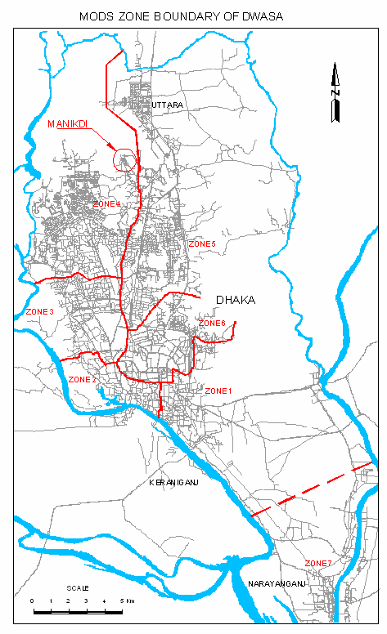

Scope of Services of the Project
The scope of this assignment is to develop Environmental Management Framework (EMF) for the sub-projects that are yet to be clearly identified and are likely to be repetitive nature (rehabilitation of sections of existing sewers and storm water drains; and WSS for low income communities). The EMF is intended mainly for use to assess sub-projects that come on board during the project period. However, it needs to be designed and tested before the project becomes effective, which would be done by the implementing agency (DWASA) of the sub-projects that are yet to be implemented during the first year. The EMF is expected to be ready by project appraisal, finalized and made publicly available.

While the Environmental Management Framework (EMF) has to be developed to address a limited number of sectors, it should be flexible tool that can be updated and expanded to cover other sectors that are agreed with the Bank for financing through the project.

As stated in the ToR, the work to be performed by the Consultant shall include the following :-

- The consultancy firm will prepare Environmental Management Framework (EMF) to ensure that sub-projects being considered for financing are environmentally sound and sustainable. The EMF should therefore include; a) guidance of environmental screening of the sub-projects to identify the nature of environmental assessment required (if any) for each sub-projects; b) guidance/ToRs for the environmental assessment to be done for the sub-projects and formulation of environmental management plans; and c) policy and legal framework, and institutional arrangements for implementation of the EMF during planning, design, construction, operation and maintenance (O&M).

- The consultancy firm will prepare “implementation manual” for the sub-project implementers. To develop the EMF, the consultants would have to work closely with staffs of DWASA and may need to get input from other relevant agencies (e.g. DPHE, DCC, NGOs, etc). The repetitive activities (where sub-projects would not be clearly identified from the beginning) for which EMF is to be developed in this project are the rehabilitation / reconstruction of different existing drains, and sewers and the WSS services to low income communities.

- The consultant would review the existing policy and legal framework with respect to relevant World Bank and National policies, laws, regulations and institutions. The review should be conducted in the light of the components of this project, highlighting the weaknesses and gaps. The consultant would summarize the relevant write up from the EA report of different sub-project. However, with regards to the administrative framework, it would consult and present the environmental roles and responsibilities at each step of the sub-project cycle (from identification to implementation) so that the implications are clear to implementing agency staffs.

- The consultant will present the methodology for screening of the sub-projects, and classifying them based of environmental risk into E1, E2 and E3 impact. A simple checklist could be developed for undertaking the classification of the sub-projects. Alternatively, since the typology of the sub-projects subjected to an EMF is likely to be known, they could also be pre-classified using financial outlay as marker for scale and nature of environmental impact.

- The consulting firm would develop terms of reference for further assessment of sub-project classified as E1 or E2 and present it in the report. A detailed EA will be required for E1 classified sub-project, a limited EA for E2 sub-project and no further study for E3 type sub-project.

- The consulting firm would present Environmental Management Plan (EMP) in two sections. A generic section, which would details out mitigation and monitoring measures to be, followed during rehabilitation and reconstruction of storm water drains and sewer lines. These would largely be good engineering construction practices to be followed (for example, pipe jacking, micro tunneling, and trench-less technologies) so that the environmental impacts are minimized and monitored. The specific section of the Environmental Management (EMP) would drive from the findings of the EA for E1, E2 and E3 category sub-projects mentioned above.

- The consultant would describe the principle, objective and approach to be followed in minimizing and mitigating the adverse environmental impacts as a result of the implementation of the project activities in EMF.

- As for the low income communities WSS programme, the EMF will need to develop an “illustrated manual” of do’s and don’ts” in local language, that would help communities to understand the environmental (health) risks that they are exposed to and how they can benefit from the programme. Help of local NGO’s should be taken in order to interact with the local communities during the development of such manual.

Scope of Services of the Sub-Projects
Environmental Management (EMP) would be carried out for all the proposed sub-projects, which is one of the main objectives of the EMF. The following sub-projects have been identified and their main objectives briefly stated as under :-

- Wastewater Management (DS-1) postponed and new project undertaken for Preparation of Master Plan for Waste Water Master (DS -1A),
- Wastewater Studies (DS-2),
- Dhaka Storm Water Drainage including two Storm Water Pump Stations at Rampura and Kamlapur (DS-3),
- Resettlement Action Plan (DS-4),
- Environmental Management Framework (DS-5),
- Dhaka WASA Performance Improvement Programme (DS-6),
- WSS Program to Low-Income Communities (DS7).
- Tracer Study (DS - 8)
- Social Safeguard Issues (DS - 9)
- Canal Development for Storm Water Drainage (DS – 10)
- Master Plan for Wastewater Management (DS – 1A), postponing DS – 1.

Wastewater Management (DS - 1) deferred and in lieu of it a new DS 1A has been undertaken

DWASA has postponed the selection procedure of DS -1 and all relevant consultants have already been informed and new DS 1A has been undertaken :

Master Plan for Wastewater Management (DS -1A).

The main scope of works under this package is to prepare the Master Plan for Wastewater Management of Dhaka City and preparation of detail design & corresponding bidding documents of some urgent activities which may, among others, consist of rehabilitation and strengthening of the existing facilities and expansion of sewerage and sanitation coverage to priority areas as identified in the Master Plan.

Wastewater Studies (DS - 2)

The main objective of this sub-project is to find out a solution so that Dhaka city can be made free from pollution arising from unhygienic disposal of sewage either from domestic or industrial and also to build up a common effluent treatment plant (CETP) at Tejgaon Industrial Area to improve the health hazard of the community. There are natural wetland/marshy land to the north of Narai Khal, which may be used for construction of wetland. Presently the Industrial wastes are discharged to the Begunbari Khal, then to Narai Khal and Balu River and polluting the Balu and thereby Shitalakkhaya River, which can be improved by constructing the CETP at Tejgaon and wetland and also to prepare a Master Plan for the Sewerage System of Dhaka City indicating the location of Sewage Treatment Plant (STP), Trunk main, Secondary & Tertiary sewers, sewage lifting stations, etc.

Time schedule to complete the following works by the consultants are about 20 weeks.

- Review the technical & financial feasibility of a common Industrial Waste Water Treatment Plant at Tejgaon;
- Conduct feasibility study for Constructed Wetland at north east of Trimohoni/Narai Khal has potential means of sewage treatment and report about the features of constructed wetland;
- (i) Review conditions under which sludge from septic tanks and latrine is currently collected of; (ii) formulate a strategy for recognizing the “industry”; and (ii) identify safe disposal arrangements; and
- Finalize ToR & RFP for Waste Water Management and Sewerage Master Plan to meet the demand upto the year 2025.

Dhaka Storm Water Drainage (DS - 3)

The title of the project is indicated for “Design and construction supervision of storm water pumping stations at Rampura and Kamlapur and drainage canals and preparation of RFP for Drainage Master Plan”. The major objective of this sub-project is to improve the storm water drainage system of Dhaka City, remove unpleasant water logging problem and floods and thereby to relieve the sufferings of the city dwellers. Preservation, Upgrading & Rehabilitation of Seven Drainage Channels and Retention Ponds within Dhaka City and Construction of Two Storm Water Pumping Stations at Rampura and Kamlapur.

The works will be divided into two Phases –

Phase I – will be completed within a period of 8 months and will constitute preparation of detail design and bid documents for storm water pumping stations at Rampura and Kamlapur, development and rehabilitation of drainage channels, recommendations for preservation & upgrading of associated retention ponds.; and

Phase II – will be to provide support to DWASA for full time supervision during the construction works over a further period of 2 (two) years. It is anticipated that between the commencement of activities of Phase I and Phase II, there may be gap of about 18 months.

Resettlement Action Plan (DS - 4)

The title of the project indicated for “Preparation of Resettlement of Action Plan (RAP) and Social Impact Assessment (SIA) for displacement of the squatter communities of the drainage canals”. Scopes of works are as under :

- Social Impact Assessment (SIA);

- Community / Stakeholder - participation / consultation;

- Resettlement Action Plan (RAP) for the canals and other sub-projects that will be included in the project;

- Design pilot project for the RAP implementation; and

- Operation manual.

In order to expedite the canal recovery work, this package has been split into 2 (two) packages – Package # DS 8 (Tracer Study) and DS 9 (Social and Safeguard Issue).

Environmental Management Framework (DS - 5)

The Environmental Management Framework (this assignment) includes the following :-

- Guidance for preparation of EMF including screening for each of the sub-projects i.e. rehabilitation of existing sewers, drains and WSS for low-income communities;
- Guidance for the environmental assessments to be done for the sub-projects and for the formulation of environmental management plans;
- Institutional arrangements for implementation of the EMF during monitoring, planning, design, construction, operation and maintenance.
- To develop “Implementation Manual” and WSS manual in Bangla..

Dhaka WASA Performance Improvement Programme (DS - 6)

The major objective of this sub-project is to improve the financial and operating efficiency of Dhaka WASA in a sustainable manner and also to recommend the improvements in overall financial management and procedures. Following tasks have been identified :

- Review of the current status of DWASA operations against the provisions of the DWASA Act, 1996 and to identify the main constraints DWASA management is faced with,
- Diagnosis of the effectiveness of the annual performance contract entered into by the Government and DWASA. The consultant shall have to determine to what extent achievements have been made by DWASA and they know these objectives, whether these are appropriate objectives to be kept in the performance contract under DWASA current strategy.
- Investment decisions;
- Procurement;
- Tariff setting and adjustment;
- Human resource management; and
- Financial Management.

WSS Program Low-Income Communities (DS - 7)

The objective of this sub-project is as under :

- An in-depth analysis of the status and challenges of WSS services in low-income communities, slum and shanties,
- Review of the existing Environmental Policy to enable sustainable and effective WSS service delivery to the low-income communities,
- Preparation of detailed database for ongoing and projected future activities in low-income communities, slum and shanties,
- To prepare a Project Implementation Manual (PIM) defining among others – (a) Principles of engagement, (b) criteria for eligibility to participate in the project by NGOs, (c) criteria for selecting NGOs to assist low income communities, (d) Monitoring indicators and mechanism to measure progress and outcome.

Tasks would have three major components, which are:-

- Preparation of Situation Map;
- In-depth situation analysis; and
- Preparation of detailed database.

Tracer Study (DS – 8)

The duration of this sub-project is only two months and the objectives are as under :

- To carry out a tracer study including census and socio-economic baseline survey of the displaced families; and other specific objectives are :
- Using DWASA’s list as a starting point and in consultation with the existing households and businesses in the vicinity of the drainage canals, trace all the displaced households and document their current and previous addresses and verify them to follow up RAP preparation activities under the project,
- To show pre-displaced houses / structures along the canals in appropriate maps in a suitable scale along with other information collected through field visits and census surveys.
- Carry out 100% detailed census survey of all affected households including socio-economic data and inventory of affected assets of displaced communities from the canals to formulate appropriate mitigation measures in conformity with the R&R policy.

Social Safeguard Issues (DS – 9)

The objective of this sub-project is as under ;-

- DWASA intends to recover some natural canals namely (i) Shangbadik Colony Khal (Mirpur Housing canals); (ii) Mirpur Housing canal - (a) Mirpur 11 to Baunia through section 10, (b) Section 6 Diabari canal through Rupnagar, (c) Section 12 staff quarter to Ibrahimpur canal; (iii) Abdullapur canal; (iv) Gerani canal (from the junction of Khilgaon Bashaboo Khal to Rajarbagh bridge to Nandipara upto Trimohoni);
- Preparation of Resettlement Action Plan (RAP) on the basis of the existing Resettlement Policy Framework (RPF);
- Conducting detailed census including socio-economic data inventory upon intensive consultation with the key stakeholders in the project;
- Conducting community meetings, focus-group discussions (FGD) and any other methods;
- Preparation of RAP following the three basic principles, which are :

  - To the extent possible, avoid or minimize adverse social impacts;
  - Enhance and improve the livelihood and quality of life for project affected people (PAP); and
  - Mitigate adverse social impacts.

Canal Development for Storm Water Drainage (DS – 10)

The main scope of works under this package is to provide services for preparation of detail design of storm water drainage canal of around 34.39 Km within the greater Dhaka City and preparation of necessary bid documents. RFP has been issued to the selected consultants with target receiving date was on the 16th August, 2007 before 3:00 PM.

Overview and Present Status of Different Sub-Projects

The objectives of all the sub-projects and scope of services are described in section 1.5.4 & 1.5.5 of this report. The key personnel of the Consultant discussed with the respective Project Directors and other personnel of DWASA who are responsible for management of different sub-packages to assess the present status of the projects. Out of 10 (ten) sub-projects only DS – 8 has so far been completed, DS -1A is under EOI stage (EOI received on 31st May, 2007, which is being evaluated by DWASA) and DS – 10 RFP and the proposals were received on the 16th August, 2007 and the rest of the packages are in progress. In order to assess the present status of the different sub-projects the Consultant has collected the status of PPF projects from DWASA as on July, 01, 2007, which are summarized and tabulated below:
Table 1: Status of different Packages under PPF Study Projects

Package # | Title of Package | Consultants | Present Status of the Project as on July, 2007 | Remarks
DS – 1  DS 1A | Wastewater Management  Master Plan for Waste Water Management | -  - | DWASA has postponed the selection procedure and relevant consultants have already been informed and in Lieu of DS -1, new project has been undertaken titled DS – 1A  EOI has been received on 31st May, 2007 and are being Evaluated by DWASA
DS – 2 | Wastewater Studies | SWECO & others | Consultant submitted the following Reports:-  - Inception Report  - Interim Report 1  - Interim Report 2  - Draft TOR for Master Plan (DS 1A)  - Draft Final Report (Feasibility Studies)
DS – 3 | Dhaka Storm Water Drainage i/c construction of two Storm Water Pump Stations at Rampur and Kamlapur | Technoconsult & others | Consultant submitted the following Reports:-  - Inception Report  - Interim Report 1  - Interim Report 2  - Draft RFP for Drainage Master Plan (DS 10) | - Rehabilitation of Seven Drainage Channels & Retention Pond  - Construction of two Storm Water Pumping Station at Rampura & Kamlapur
DS – 4 | Resettlement Action Plan (RAP) | DPM & Sheltech | Consultant submitted the following Reports:-  - Inception Report  - SIA Report  - Consultation Report  - Resettlement Action Plan (RAP) Report (Draft)  - O&M Manual  - Field Survey has been completed | Original DS 4 has been divided into two components :  DS 4 Resettlement Action Plan and  DS 9 Social Safeguard Issues
DS – 5 | Environmental Management Framework | BETS | Consultant submitted the following Reports:-  - Inception Report  - Interim Report  - Draft Final Report (this Report)
DS – 6 | Dhaka WASA Performance Improvement Programme | SODEV & others | Consultant submitted the following Reports:-  - Inception Report  - Draft Diagnostic Report  - Communication Strategy  - Final Diagnostic Report  - Draft Final Report
DS – 7 | WSS Programme to Low Income Communities | DAVECON | Consultant submitted the following Reports:-  - Inception Report  - Workshop with stakeholders completed  - Final Project Proposal & PIM  - Project Document (Draft)
DS – 8 | Tracer Study | CUP | Project Completed & Report submitted | Project Completed
DS – 9 | Social Safeguard Issue | AQUA | Consultant submitted the following Reports:-  - Inception Report  - Draft RAP
DS – 10 | Canal Development for Storm Water Drainage | - | Clearance from the World Bank on short listing has been received on June, 28, 2007. | World Bank made some comments on the revised RFP on June 28, 2007. Now RFP issued to the selected bidders with expected date of receiving the proposal on the 16th August, 2007.

User’s Guide

Purpose of this Document
This Environmental Management Framework (EMF) document is intended to document necessary guidance to the organization of DWASA for taking strategic decision-making levels during implementation of different ongoing sub-projects or new projects. The document has been developed with the purpose of promoting and ensuring environmental legal compliance and achieving environmental sustainability through the promotion of sound environmental management practices by DWASA.

As a strategic environmental decision-making framework, the document is neither prescriptive nor does it include excessive information, rather it provides general guidelines for the EMF components. Provision of more detailed information, application and/or implementation guidance forms an integral part of the capacity building and successful implementation of the ongoing sub-projects or new projects without any adverse environmental impacts/degradation. As a supplementary tool this document is annexed with the “Project Implementation Manual – in English” and Bangla WSS manual for Low Income Communities – summarizing ‘what to do and what not to do’.

This document is recommends to make available to the public &/or in the website of DWASA, so that everybody can be benefited and overall environmental improvement is achieved among the concerned departments of Bangladesh who are responsible for implementation of various development works in their related disciplines.

EMF Structure and Contents
The EMF document is structured in a sequential manner to assist the reader to understand the background of preparing the document, purpose, objectives and basis for developing the EMF and thorough understanding what components makeup the EMF and how these components are integrated during the study, detailed design, implementation/rehabilitation and O&M stage of any future projects. The chapter-wise descriptions are stated briefly as under :

Chapter 1 provides background information to the need for the Environmental Management Framework and information about the project authorization, objective of the report, the consultant’ mobilization and setting up office and background of the project detailing the scope of services and overview of the different sub-projects with their present status, etc.

Chapter 2 (this chapter) provides sufficient information for the user of the document.

Chapter 3 provides background information about DWASA, its activities, services, partial organogram and concerned departments responsible for execution of the EMF including the water quality testing and laboratory facilities.

Chapter 4 provides overview of the environmental policies, rules and regulations related to the EMF for both national & international policies and overview of the international EA guidelines, Environmental Impacts, Management and Magnitudes of Impacts as per E1, E2 & E3 classifications. This chapter also includes the existing conditions of water supply, sewerage and Storm water drainage including the relationship between EIA and project components. It also outlines with Environmental Assessment Guidelines including procedure for Environmental Clearances, etc.

Chapter 5 provides comprehensive information about the Strategic Environmental Assessment, Environmental Impacts Assessment, Environmental Management System, Environmental Monitoring Mechanism, and Risk Assessment – both human and ecological risk.

Chapter 9 provided Gap Analysis of the present EMF of DWASA, which mainly focuses the weakness of laws, policies, etc which needs to be amended in due course.

Chapter 7 provides designed / improved Checklist and Screening of various sub-projects, adaptation / testing of the checklist for different ongoing sub-projects, methodology for screening of sub-projects and consultation with the prospective stakeholders,

Chapter 8 provides most pertaining information about the EMF, vision, aims and objectives of EMF, outlining EMF with DWASA, identification of policy, policy development, implementation, monitoring, review and undertaking development projects including the roles and responsibilities of EMF process, etc

Chapter 9 provides Conclusions and Recommendations

Annexure 1 Adaptation of Checklist for DS1A to DS 10
Annexure 2 Project Implementation Manual in English

Annexure 2 WSS Manual for Low Income Communities – what to do & not to do.

How to use the Document

- The readers requiring details of the functions of EMF, its vision, aims & objectives, purpose, identification of policy, development of policy, monitoring & review, should only read the chapter 7 of this report.
- Those who are interested about the structure of the checklist, its weightage and adaptation of this checklist for different sub-projects, they should read only chapter 6 of this report.
- The readers who are interested to read Environmental Assessment and Management tools including Environmental Risk assessment for human and ecological risks, they should read chapter 5 only.
- On the other hand the Environmental Policies, Rules, & Regulations, including existing environmental conditions, existing sewerage & drainage conditions of Dhaka city are described in details in chapter 4. This chapter also included with the relationship between the EIA and other project components, environmental guidelines, and environmental clearances, etc.
- Chapter 3 of this report provides information about the key functions of DWASA, its institutional strength and the Environmental Cell & its Laboratory facilities, who will be responsible for the implementation of the EMF.
- Readers who are interested to know about the user’s guide should read chapter 2 of this report and
- Chapter 1 of this report deals about the objectives of this report, background information about the project, scope of services of the project, scope of works of different sub-projects and their up-to-date status including the consultant who was engaged to document this report.
- Besides, the Table of Contents (TOC) will give the detail headings & sub-headings of each chapter with page number and the list of Tables and Figures have been provided after the TOC and list of acronyms and abbreviations also provided for easy understandings of the terms used in the report. Moreover some important foot notes have been given in the respective pages of the report.
- In addition those who are interested to read the “Project Implementation Manual” they should read the Annexure 2 (in English) and those who are interested to read the “WSS manual for the low income communities” (in Bangla), they should read the Annexure 3 only.

Beneficiaries of the Document
This document in intended for use by anyone who :-

- is directly appointed as “Environmental Consultant” by any other organization;
- is directly involved for the implementation/rehabilitation of any of the current sub-projects, financed by the World Bank, or such new projects within DWASA;
- requires an understanding of the environmental legal compliance requirements for functions, activities or projects implementation procedures of DWASA;
- needs to know the recommended environmental management roles and responsibilities of DWASA;
- needs to know that which environmental management and assessment tools are incorporated in the EMF and how they are integrated with project cycle approach to be applied by DWASA;
- needs to know how the Environmental Management Plan (EMP) is applied within the department of DWASA;
- requires an understanding of the structure and functioning of the EMF recommended for DWASA;
- is engaged for rendering the consultancy services for feasibility study, detailed design, construction supervision and O&M
- is engaged for preparing EMF for any other organization, other than DWASA;
- is engaged for providing WSS services to any urban/rural communities, funded by the international donor agency or GoB or by NGO.
- Students who are interested to learn detailed Environmental aspects.

Overview of DWASA

Introduction
DWASA is a public service institution, operating on a commercial footing. It is mandated to carter to the water supply, sewerage and storm water drainage services to the dwellers of metropolitan Dhaka City and Narayanganj town through 7(seven) MODS Zones, of which Narayanganj town served by MODS Zone 7. Apart from its aforesaid major functions, its ordinance allowed it to produce pure bottled water to serve the people alongside similar bottled water producers. In all its efforts, DWASA remains fully aware of and responsive to the overall environmental requirements of its own domain and beyond. In its service delivery DWASA, it continually interacts and coordinates with its fellow urban entities namely DCC, RAJUK and other service producers so as to remain fully conversant with overall urban development stipulations of the Government of Bangladesh. DWASA is obliged to extending its service to the poor enclaves and slums which conforms to the poverty reduction aspirations of the Government. The major services including standards, quality and time frame and how/where to get them specifically includes but not limited to the following:

Water Supply :

- Production of both surface (18%) and groundwater (82%) with conjunctive use and supply of potable water on a round the clock basis in conforming to the country’s acceptable health standards through about 2,500 Km of distribution mains to the domestic, commercial and institutional entities within its service area of about 400 sq km and services provided to the population of about 10 million
- Ensure proper operation and maintenance of the total water supply system including 465 DTW, three SWTP one at Saidabad, other at Chandnighat and one at Narayanganj. About 60% of the DTW are installed with standby generators and almost 100% DTW are equipped with chlorination facilities.
- In case of any emergency breakdown disrupting the supply due to technical or any other reasons, organize supply of water to meet the demand of the consumers at a specific rates by using the tank lorries belonged by DWASA through the respective MODS Zones and Field maintenance Division of DWASA.

Sewerage :

- In specific areas (covering about 20% of the city dwellers), collect and transmit liquid wastes from domestic, commercial and industrial units through piped sewer of about 881 Km and undertake their pre-disposal treatment before final disposal
- Ensure continuous monitoring of the O&M aspects of the system and keep it fully operational and functional.

Storm Water Drainage :

- Install, operate and maintain about 233 Km of underground conduits of storm water drainage & 65 Km of open channel and 8 Km of Box culvert in an efficient manner for timely collection and disposal of storm water and non-sanitary waste water generated by households and other units
- Organize and manage prompt disposal of stagnated water from any area under its domain by using direct pumping
- DWASA deals with the Primary Storm Water Drainage facilities and whereas the DCC deals with the Secondary & Tertiary drainage works within the Metropolis.

Overview of DWASA

Organogram
DWASA prepared and proposed a new organogram to the Government which has been under active consideration of the Government for its approval and it took long time for its approval and finally the First Organogram has been approved by the Government in November, 2007. The DWASA Act was promulgated in 1996 with a view to grant more autonomy to DWASA by reconstituting and strengthening the DWASA BOARD, introducing commercial regulations reducing Government’s role etc, provided the First Organogram to be approved by the Government, which took long time for its approval and finally approved in November, 2007.

Due to migration from rural areas Dhaka City has witnessed major growth in population over the last few decades. Within next 20 years, Dhaka will be among the 10 most densely populated mega cities of the World with estimated population of about 25 million. DWASA is striving hard to keep pace with the rapid expansion of the city both horizontally and vertically. But due to limited resources of DWASA both financial and human, many of its development initiatives are being restricted. In order to meet the increasing demand of Dhaka City, many development partners have been showing their interest to assist DWASA to overcome the situation and improve the utility services.

However full organogram shall not be shown here, rather the top management structure is as under :

Figure 2 : New Organogram (Top Management Part only)
MANAGING  DIRECTOR  DMD (O&M)  DMD (RP&D)  DMD (Finance)  Chief Engineer  (O&M) |  |  | DWASA BOARD
 |  |  |  |  |  |  |  | DMD (Admin)
 |  | Addl. Chief Engr.  (RP&D) |  |  | Commercial Manager |  |  | Secretary
In the above approved Organogram, which was prepared by DWASA during mid 1990’s, there is provision of Environmental Monitoring Division under the P&D Circle, headed by one Environmentalist (equivalent to the Executive Engineer) with only 6(six) staffs and the Additional Chief Engineer (RP&D) is the controlling officer. May be at that time it was appropriate, but due to increasing demand the government has created the Environmental Cell Circle, which has been functioning till to-date. That means the Organogram needs immediate revision to cope up with the Environmental activities properly and efficiently especially to deal with the present EMF.

DWASA Environmental Cell

Background

In order to meet the increasing water demand of the population of Dhaka City and in order to address the continual depletion of the ground water table at the rate of 2 to 3 m per year, including mining in many areas, DWASA has no other choice but to increase utilization of the surface water sources from its present 18% till equalization and on the other hand to reduce the extraction of groundwater source from its present 82% till equalization (preferably to reverse the situation i.e. 80% from surface water source and 20% from groundwater source). But the raw water quality of the peripheral river of Dhaka City has been deteriorating day by day, although the quantitatively raw water is sufficient to meet the long term domestic water demand, only water quality is to be ensured. In order to achieve the goal, the Environmental Protection Zone around the Shitalakkhaya and its tributary Balu River must be kept free from industrial pollution and other human pollution.

Requirement of Environmental Cell

During implementation of the Fourth Dhaka Water Supply Project, the World Bank recommended that DWASA should be responsible to control the river pollution within the environmental protection zone. As such DWASA felt the need of Environmental Cell and created the same within DWASA with some specific objectives. This would essentially need effective profound scanning of DWASA’s technical and managerial skill-base, and propose the structure that has adequate institutional capabilities, both in respect of human resources, logistic & equipmental and other requisite support to monitor the compliance of environmental laws, rule & regulations and carry out environmental actions.

Objectives of the Environmental Cell

The overall objectives of the DWASA’s environmental Cell, in respect of addressing the environmental issues related to water, sanitary sewage and storm water drainage of Dhaka City along with developing / improving the existing water quality monitoring mechanism for DWASA, would specifically include the following :

- Develop strategies, procedures and systems to monitor the pollution levels of the peripheral rivers as well as groundwater quality on regular basis;
- Ascertain quality requirement parameters of the peripheral river which would be acting as raw water source of water supplies;
- Develop a sound environmental awareness programme for public and pertaining agencies i.e. DCC, RAJUK, BWDB, DoE;
- Disseminate environmental information to various stakeholders;
- Establish quality control procedures to support, control and develop sound water quality testing laboratory within DWASA;

Scope of Works of the environmental Cell

The scope of works of DWASA’s Environmental Cell is as under ;

- To conduct survey of the pollution sources along the peripheral rivers of Dhaka City;
- To pursue the new Environmental Legislation;
- To monitor the environmental pollution on regular basis;
- To monitor the groundwater quality on regular basis;
- To monitor the impacts of industrial, domestic and agricultural wastes into the peripheral rivers on regular basis;
- To enforce the environmental regulations to protect the environmental protection zone;
- To ensure compliance of the environmental regulations for the nearby industries where effluent from the industries are discharged into the river without treatment;
- Any other activity to fulfill the overall objectives of DWASA.

Present Manpower for the Environmental Cell

The Environmental Cell of DWASA has been sanctioned / approved by the Government headed by the Superintending Engineer, Environmental Cell and 3(three) Executive Engineers ( XEN – East and West) and the sanctioned posts and present status of manpower for the Environmental Cell are shown below:

Table 2 : Sanctioned Manpower of existing Environmental cell Circle, DWASA

Sl # | Name of Post | Approved # of Post | Present # of Staffs | Remarks
 | Environmental Cell Circle Office
1 | Superintending Engineer | 1 | 1
2 | Water & Sanitation Specialist | 1
3 | Hydro-geologist | 1
4 | Assistant Legal Advisor | 1
5 | Stenographer / PA | 1
6 | Accounts Officer / UDC | 1
7 | Office Assistant / CA | 1 | 1
8 | Driver | 1 | 1
9 | Peon / MLSS | 1 | 1
10 | Messenger Peon | 1
 | Sub-Total | 10 | 4
 | Executive Engineer (East)
1 | Executive Engineer | 1 | 1
2 | Assistant Engineer/Sub-Divisional Engr. | 2 | 1
3 | Sub-Assistant Engineer | 3 | 1
4 | Accounts Officer | 1
6 | Office Assistant / CA | 1 | 1
6 | Driver | 1
7 | Peon / MLSS | 1
 | Sub-Total | 10 | 4
 | Executive Engineer (West)
1 | Executive Engineer | 1 | 1
2 | Assistant Engineer/Sub-Divisional Engr. | 2 | 1
3 | Sub-Assistant Engineer | 2
4 | Accounts Officer/UDC | 1
6 | Office Assistant / CA | 1
6 | Driver | 1
7 | Peon / MLSS | 1
 | Sub-Total | 9 | 2
 | Total | 29 | 10

From the above table it is noted that in total there are 29 sanctioned posts under the Environmental Cell of DWASA. But at present only 10 staffs are working. On an average about 35% of the sanctioned posts are lying vacant within the Environmental Cell Circle.

On the other hand as per approved First Organogram of DWASA, there is no provision of Environmental Cell Circle, only Environmental Monitoring Division has been kept under the P&D Circle with the following :

Present Manpower of the Environmental Monitoring Division as per the Organogram of DWASA consisting of only 6(six) personnel, which are as under :

- Environmentalist (equivalent to the executive Engineer) = 1 #
- Assistant Environmentalist (equivalent to Assistant Engineer) = 1 #
- Research Officer = 1 #
- Assistant Quality Assurance Officer = 1 #
- Office Assistant cum Data Entry Operator = 1 #
- M.L.S.S = 1 #

DWASA Laboratory
DWASA has been maintaining a modern laboratory for testing water quality parameters where they are able to measure the turbidity, pH, Temperature, Dissolve Oxygen, BOD, COD, TDS, Chloride, Alkalinity, Acidity, Calcium, Iron, Ammonia, Chromium, Zinc, Cyanide, Copper, Aluminum, Residual Chlorine, Total Coliform, Feacal Coliform, Aluminum Sulphate, Chlorine, Nitrate, Sulphate Manganese, Colour and Arsenic, etc.

But again according to the new approved Organogram there are (a) One Microbiology Division, consisting of 12 personnel, and (b) One Chemical Division, consisting of 11 personnel.

The present laboratory has been maintained by the Executive engineer, DWASA Quality Control and Research, under the Environmental Cell. The laboratory is equipped with the following instruments and equipments :

- Computer
- Oven
- Refrigerator
- Incubator
- Electric Balance
- Spectrometer
- Furnace Control
- Fumehood , Lab Konco
- Conductivity / TDS Meter
- Water Berth, Temperature
- Magnetic Stirrer
- Colony Counter
- Turbidity Meter (NTU)
- Decicator
- Chlorine kit
- Microscope
- Illuminator
- pH Meter
- Incubator Oven (200 degree)
- BOD Incubator
- Dissolve oxygen
- Incubator Oven – model 6
- Arsenic Kit

Capacity Building
Based on the sanctioned strength of its staffs and available laboratory equipment it is noted that the Environmental Cell of DWASA is well equipped but institutional capability remains unsatisfactory due to the fact that about 35% of the posts are lying vacant. Similar scenario is prevailing with respect to the testing facilities and capabilities of the laboratory, because there are about 56% of the sanctioned posts are lying vacant.

As per EMF all environmental aspects should be dealt with by the Environmental Cell and as such it is strongly recommended that all the vacant posts should be filled up soon and all laboratory equipment should be brought under operating conditions. The unserviceable equipments should be replaced with some modern equipment.

It is recommended that in order to cope up with the gigantic tasks under the EMF, the Environmental Cell should be re-organized by increasing the sanctioned posts and the laboratory should be well equipped in all respect so that DWASA is self sufficient for testing all necessary water quality parameters in connection with the surface and groundwater quality monitoring process.

Nevertheless, the new Organogram needs immediate revision to accommodate the Environmental Cell Circle with two Divisions, otherwise, the only Environmental Monitoring Division with only 6(six) manpower, is absolutely inadequate to manage the environmental activities of the EMF under DWASA. Recommended Organogram of environmental Cell :-
Addl. Chief Engr.
(RP&D)

Environmental Cell
10 Staffs

Division – 1
10 Staffs

Division – 2
9 Staffs

Environmental Policies, Rules & Regulations related to EMF

Environmental Laws, Regulations and Guidelines
DWASA environmental assessment exercises must obviously be carried out within the framework of current GoB environmental policies, rules and regulations. For water supply and sanitation projects, the most relevant policies are detailed in Section 4.2.1 (Table 2). The regulations contain provisions regarding conservation of the environment and control of environmental pollution from various sources. Usually the environmental issues in the country are handled by different sectoral policies and legislation, such as land use, water and air pollution, toxic chemicals, noise, solid wastes, wildlife protection, forest conservation, environmental health and sanitation and industry. The sectoral laws dealing with different environmental issues in Bangladesh were enacted at different periods. They were useful at the time they were enacted, but many not now completely answer present development needs. Moreover, the environmental concerns and priorities of the country have changed considerably since the laws were passed. For environmental management in particular, updating of some laws is needed. This is being undertaken by the Department of Environment (DoE).

The legal system of Bangladesh is potentially strong, but lacks specific enforcement mechanisms to enable these laws to be really effective. Hence there are ownership of conflicts, claims and counter claims regarding the private and public domains. Of special importance to the water sector is the lack of enforcement mechanisms for water pollution control, such as industrial and wastewater effluents discharged into natural water bodies.

Many environmental reports and handbooks are in use or are being prepared in Bangladesh, and are too numerous to describe separately. For the Water Resources Sector the key documents are the Environmental Assessment Guidelines (WARPO, 2005) and the EIA Manual (FPCO, 1992). These were originally intended for use in the study and environmental evaluation of plans and projects proposed under the Bangladesh Flood Action Plan (FAP).

Environmental Quality Standards (EQS) have been prepared as set of guidelines to assist with government policies regarding environment pollution control and environmental protection (MoEF, 1997). They are also intended to guide, monitor and enforce procedures by DoE.

Overview of Environmental Policies, Rules and Regulations related to EMF
To deal with various pollution problems created by human action or by the implementation of development work in Bangladesh, numerous policies, rules and regulations have been enacted. These regulations contain provisions regarding conservation of the ecosystem and control of environmental pollution from various sources. The sectoral regulations deals with different environmental issues in the country were enacted at different periods.
The water supply system and sanitation components shall go through the environmental requirements of the Government of Bangladesh (GoB). Section 7 of the Environmental Conservation Rules of 1997 mandates that an Environmental Clearance Certificate (ECC) shall be secured for specific types of projects. Of the various components of the Project, only the water treatment plants and public toilets are within the purview of the EIA system of GoB. Schedule 1 of the Act classifies public toilets under Orange B (E2) Category while water treatment plants are under Red Category (E1).
The documents to be submitted to the concerned Divisional Officer of the DoE for Orange B Category (public toilets) and Red Category (water treatment plant/effluent treatment plant) are as follows:
- Accomplished Form-3: Application for Environmental Clearance Certificate (ECC)
- Report on the feasibility of the project;
- For Orange B Category (E2): Report on the Initial Environmental Examination (IEE) of the project, and also the process flow diagram, Layout Plan and design of the Effluent Treatment Plant (ETP);
For Red Category (E1): Report on the Initial Environmental Examination (IEE) relating to the project, and also the terms of reference for the Environmental Impact Assessment (EIA) of the unit or the project and its Process Flow Diagram; or EIA report prepared on the basis of terms of reference previously approved by the Department of Environment, along with the Layout Plan (showing location of Effluent Treatment Plant), Process Flow Diagram, design and time schedule of the Effluent Treatment Plant of the unit or project, (these are applicable only for a proposed project)
- Report on the Environmental Management Plan (EMP) for the project, and also the Process Flow Diagram, Layout Plan (showing location of Effluent Treatment Plant), design of the Effluent Treatment Plant and information about the effectiveness of the ETP of the unit or project, (these are applicable only for an existing project);
- No objection certificate (NOC) from the local authority;
- Emergency plan relating to adverse environmental impact and plan for mitigation / monitoring of the effect of pollution; and
- Outline of the relocation, rehabilitation plan (where applicable).

The list and description of current legal and regulatory framework related to water supply and sanitation projects are presented below.
The following Table presents the national policies, rules and regulations.

National Policies
The National regulations govern the environmental aspects of water resources and sanitation sectors in Bangladesh. The following Table summarizes some of the important national environmental policies, rules and regulations.

Table 3: Relevant laws and regulation on water supply and sanitation project
Reference | Description
National Water Policy, 1999 | The Policy makes provisions for planning and development of the water resources sector and include environmental and social provisions
National Policy for Safe Water Supply and Sanitation, 1998 | The policy calls for nationwide access to safe drinking water and sanitation services at an affordable cost
EIA Guidelines for Industries, 1997 | The Guidelines includes EIA procedures for industries and also for water development projects.
National Environmental Management Action Plan (NEMAP), 1995 | The NEMAP outlines the policies relevant to health, sanitation and population control and identified the key environmental problems in this sector.
Environment Policy of 1992
Section 3.3: Health and Sanitation | Requires prevention of harmful impacts in all areas and development activities in the country (Sub-section 3.3.1)
Section 3.5: Water Development, Flood Control and Irrigation | Requires environmentally sound utilization of all water resources (Sub-section 3.5.1)
Section 3.5: Water Development, Flood Control and Irrigation | Requires prevention of adverse environmental impact of water resource development projects and irrigation networks (Sub-section 3.5.2)
Section 3.5: Water Development, Flood Control and Irrigation | Requires sustainable, long term, environmentally sound and scientific exploitation and management of the underground and surface water resources (Sub-section 3.5.6)
Section 3.5: Water Development, Flood Control and Irrigation | Requires conduct of Environmental Impact Assessment before undertaking projects for water resources development and management (Sub-section 3.5.7)
Environment Conservation Act of 1995
Section 12: Environmental Clearance Certificate (ECC) | Requires all industrial units or projects to obtain an ECC from the DOE prior to implementation
Environment Conservation Rules of 1997
Section 7: Procedures for issuing ECC | Spells out procedures and documentation requirements for obtaining ECC for different project category
Schedule 1 | Classification of industrial units or projects based on location and impact on the environment
Schedule 3 | Standards for ambient water quality and drinking water quality
Schedule 10 | Standards for effluent from industrial units and projects
The Groundwater Management Ordinance, 1985 | An Ordinance to manage the groundwater resources for agricultural and drinking water purpose.
Pesticide Ordinance, 1971 | An Ordinance to regulate the import, manufacture, formulation, sale, distribution and use of pesticide.
Water Supply and Sewerage Authority Ordinance, 1963  Dhaka WASA Act, 1996 | An Ordinance to provide construction, improvement, expansion, operation and maintenance of water and sewerage work, and Drainage system relating to environmental sanitation.

International Policies

UNICEF

UNICEF and the Sanitation Working Group of the Water Supply and Sanitation Collaborative Council worked with Environmental Health Project (EHP) in promoting appropriate environmental sanitation policies and effective sanitation programming tool kits. UNICEF is the major development partner in the Rural Water Supply and Sanitation Sector all over Bangladesh.

World Health Organization (WHO)

WHO works on aspects of water, sanitation and hygiene development, wastewater use, water related disease, issues in water and infectious disease etc. Functions of WHO include: (a) articulating consistent, ethical and evidence-based policy and advocacy positions; (b) setting, validating, monitoring and pursuing the proper implementation of norms and standards etc.

World Water Forum

The World Water Forum is a World Water Council initiative, which aims to raise awareness on water issues all over the World. The main international event on water, it seeks to enable multi-stakeholder participation and dialogue to influence water-policy making at a global level.

UN Millennium Development Goals

The UN Millennium Development Goals (MDG) comprises eight goals. The International Federation has set its water and sanitation targets to meet those goals.

Overview of the International EA Guidelines
A 1. World Bank

The World Bank (WB) Environmental Sourcebook in three volumes (1991) gives extensive reference and training material for EIA work; with (to date) 26 updates published between 1998 and 1999. There is also the Pollution Prevention and Abatement Handbook (WB 1999).

The old WB EA Operational Directives are being reformatted to sets of Operational Policy, Bank Procedures and Good Practices (OP, BP and GP respectively), the sets most relevant to EA at present consisting of:

OP/BP/GP 4.01 Environmental Assessment
OP/BP/GP 4.02 Environmental Action Plan
GP 4.03 Agricultural Pest Management
OP/BP/GP 4.04 Natural Habitats
OP 4.07 Water Resources Management
OP 4.09 Pest Management
OD 4.20 Indigenous Peoples
OD/GP 4.36 Forestry
OP/BP 4.37 Safety of Dams
OP/BP/GP 7.50 Projects on International Waterways
OP/BP/GP 7.60 Projects in Disputed Areas
OP/BP/GP 8.50 Emergency Recovery Assistance

The proposed Environment and Social Unit can review these selected documents during preparation of project specific environmental reports by the ESU or by the Consultant.

A 2. Asian Development Bank, Environmental Assessment Guidelines, 2003

ADB has classified water supply and sanitation project, as Category B for Environmental Assessment and therefore, an IEE is required. The process of determining a project’s environment category is to prepare a Rapid Environmental Assessment (REA) screening checklist, taking into account the type, size, and location of the proposed project. A project is classified as one of the four environmental categories (A, B, C, or FI) as follows:
- Category A: Projects with potential for significant adverse environmental impacts. An environmental impact assessment and a summary EIA (SEIA) are required to address significant impacts.
- Category B: Projects judged to have some adverse environmental impacts, but of lesser degree and/or significance than those for category A projects. An initial environmental examination and a summary IEE are required to determine whether or not significant environmental impacts warranting an EIA are likely. If an EIA is not needed, the IEE is regarded as the final environmental assessment report.
- Category C : Projects unlikely to have adverse environmental impacts. No EIA or IEE is required, although environmental implications are still reviewed.
- Category FI : Projects are classified as category FI if they involve a credit line through a financial intermediary or an equity investment in a financial intermediary. The financial intermediary must apply an environmental management system, unless all sub-projects will result in insignificant impacts.

For Category B projects, the draft IEE, as well as SIEE, which highlights the main findings of the IEE, is reviewed by ADB’s Regional Department sector division and then Environment and Social Safeguard Division and the . All comments are to be incorporated into the final documents. The project and the national environmental protection agency (i.e. the DoE) make a final review of the IEE and SIEE reports. Then officially submits the reports to ADB for submission to the Board of Directors.

A 3. Asian Development Bank Environmental Guidelines by Sector

The ADB has published a series of Sector Guidelines, covering 20 sectors and sub-sectors (ADB 1990-1991), Environmental Papers covering several matters relevant to EA (ADB, various dates) and the two-volume EIA Guidelines for Developing Countries in Asia (ADB 1997).

A 4. Japan Bank for International Cooperation (JBIC)

JBIC considers that, environmental conservation is one of the major challenges to the global community. Environmental and social considerations thus constitute an essential element in JBIC operations. In individual projects it finances, JBIC confirms that the project proponent makes appropriate environmental considerations. JBIC has established the Environmental Guidelines on April 1, 2002 to conduct International Financial Operations and Overseas Economic Cooperation Operations respectively. The Guidelines has been implemented from October 1, 2003. The Guidelines also encourage project proponents to make appropriate environmental and social considerations as well as to assess their measures effectively and efficiently.

A 5. The European Union

The Commission of the European Union (formerly the European Communities) produced a guideline to the procedures for assessing environmental impacts of projects and programmes financed by the European Union (CEC 1992). This outlines the definition and scope of EIA, including both natural and social environments, and gives a flow chart showing how this is to be incorporated into the project planning process.

Study of Existing Environmental and Social Condition

Environmental Condition
Environmental and Social consequences should be recognized early in the project cycle and taken into account in project selection, sitting, planning and design. EA identifies ways of improving a project, which is environmentally & socially preventing, minimizing, mitigating or compensating for adverse impacts as appropriate for individual project. By paying attention to environmental and social issues early and by involving stakeholders in meaningful consultations, ultimately the EA allows the project cost-effective.

Environmental degradation is taking place in the capital city due to uncontrolled discharge of liquid and solid waste in our environment from domestic, commercial and industrial wastes. Dhaka is surrounded by Rivers Buriganga, Sitalakhya, Turag and Balu and all these Rivers are the sources of surface water for various uses of the city dwellers. Industrialists are also using water for processing their products but they are discharging the industrial wastes to the river without any treatment. Besides the point and non-point sources of the direct discharge of waste water in the above mentioned rivers and other channels. Ultimately these are considered major sources of waste water pollution both domestic and industrial into the environment. It is a scenario of uncontrolled discharge of waste water into the environment.

Sources of pollutions are identified as under :

- Human wastes (body waste & sullage water),
- Industrial wastes (both liquid & solid),
- Solid wastes (domestic, commercial & clinical)

Social Condition
Dhaka was founded in 1608 AD and referring to a profile of DCC it shows that during 1900 the population was less than 50,000 within an area of 16 sq km. The present population is estimated at 1.0 million within an area of 350 sq km distributed within 90 administrative wards. The present growth rate is about 5 to 6 percent. The city economy is predominately dependant on its industry/ commercial development and as a capital city it accommodates all central government institutions. The weight of the industrial / commercial development will definitely fall on the environmental conditions which have been already deteriorated and exceeded the acceptable limits. The existence of the urban poor group of people estimated at more that 30% of the total population requires approach with low cost sanitation facilities with an emergency requirement since they are the most affected and exposed to pollution group of residents in the capital city. But we all know that the existing status of the sanitation infrastructure has considerable deficiencies in itself which integrated as services to the population of the capital city gives a very grey picture of the living conditions. The water supply system is reported to be about 30% below the demand level. At present water abstraction rates about 82% from the main water source (deep tube wells) for Dhaka, the underground aquifer is depleting with a rate of 1 to 3 meter per annum whereas about 18% of the total demand is met from the surface water.

Existing Sewage Condition
It is rather difficult to asses the real extent, master plan and modes of operation of the sanitation system in Dhaka City. Overall studies and plans on sanitation system covering the whole area are from the early eighties, thus data and information are to be considered back dated. The investigation verified the existence of various sanitation system and those are classified in four main categories.

- Separate Sanitation System
a. conventional sewerage system
b. Small-bore sewerage system

- Combined Sanitation system
a. direct user connection
b. indirect user connection

- On-lot Sanitation system

  - Septic tanks with individual soak well or discharge in a water body
  - Temporary pit latrines, sanitary latrines, hanging latrines and other latrine type facilities

- Non-Sanitation system

The industrial sector without any evidenced exception in whole of Dhaka City is discharging their raw waste water into the nearest possible recipient regardless what it is viz, pipe, open drain, khal, retention basin or even washout from the road surface and in other words the scenario is uncontrolled discharge. The system is not function properly because of the following reasons :

- Deficiency in pipe diameter (resulting blocks)
- Deficiency in proper pipe gradient
- Blocked/broken man-holes
- Improper design of man hole cover ( resulting frequent theft)
- Inefficient operation and maintenance of the treatment plant and sewer network system as a whole.

Present water production is about 1600 mld of which 70% is considered as average DWF for sewage flow, which is about 1120 mld; 25% coverage and thus sewage in the network is 280 mld. Average daily sewage treated at Pagla STP is 40 mld (dry season as per log book) and therefore percentage treated is about 14.28%.

Three major sanitation sector performance viz sewerage, drainage and solid waste have cumulative negative impact on the living conditions in Dhaka and their separate (non) performance is influenced by each others deficiencies.

Existing Drainage System
The first drainage works was started in the city by the DPHE in the year 1964 and the department handed over 160 Km drainage net-work, to DWASA in the year 1989. Since the handing over of the facility the drainage was never a major issue, because the natural khals functioned normal and unhindered. Following the 1988 floods the government initiated a crash flood control programme for Dhaka City which culminated the birth of Dhaka Integrated Flood Protection Project (FAP-8B).

Morphologically Dhaka city is situated in a flood prone area. The drainage system in the area comprise several depressions, retention ponds, lakes and other primarily submerged low lying lands linked to the surrounding river network. There were more than 40 channels with catchments areas varying between 6 to 40 Sq Km. In a normal flood, the average depth of water in the low-lying area rise by between 1 and 2.5 m during the monsoon season from June to October. Frequency analysis indicates that approximately 60% of the city area lies below the mean annual maximum flood level.

The current situation is that there is overlapping areas of control for the various aspects of the drainage problem of the city. DWASA was entrusted with the works of component “B” of DIFP Project consisting of primary, secondary and small part of the tertiary drainage system. Besides this the drainage problem of a large part of the old town (675 ha) along with construction of a 20 cumec capacity pump station were executed by DCC known as Dholai khal component. The Dholai khal and Kallyanpur pump station are operated by DWASA. The 20 cumec capacity Goran Chatbari drainage pump station is operated by BWDB.
Present scenario is that all low lying areas have been developed by the private developers in an unplanned manner. Natural canals / khals have been encroached unauthorized way consequently all roads are being submerged with a medium rainfall.

Pumps galleries have been installed by DWASA at Rampura Bridge Point and Janapath under Drainage System to pump out the flood water from the developed city side to outside (river side).

Environmental Assessment Process for the Sub-Projects
The environmental assessment process for all the sub-projects have been categorized as follows :-

- Feasibility Study (FS);
- Detailed Design;
- Construction and Implementation;
- Operation and Maintenance (O&M)

The Project Planning, Feasibility Study, Implementation and EIA Process have been shown in Figure # 3

Relationship between EIA and Feasibility Study
The above statement drags the issue of Pre-feasibility/Feasibility study stage as shown in Figure # 3. It is highly advantageous for the EIA to be done essentially as part of the Feasibility Study process due to the following reasons :

- that the findings of the EIA team can be considered by the FS project design team as the FS proceeds and that the FS project design team can make effective use of these findings while preparing the FS, rather than having to redo the FS later to accommodate the essential environmental impacts, which will not only increase the FS costs but also slow down the project implementation process while waiting for the FS to be revised, and
- that the EIA team can make effective use of the detailed information being prepared by the FS design team for EIA purposes and thus avoid duplication of effort which occurs where the EIA team works independently of the FS project design team and tries to collect and generate the necessary data on its own.

Relationship between EIA and Detailed Design
The process and the methodology depend on the magnitude of the project. From Figure # 3 it can be seen that once the sub-project is identified then it is processed for IEE and normally for a small project there will be no significant environmental impacts (SEI) and as such the IEE becomes the completed EIA. If the project will result in significant environmental impacts then the design consultant must make necessary design concession in order to reduce the negative impacts vis a vis cost consideration and benefits in all aspects of the design.

Relationship between EIA and Construction and Implementation
During construction, implementation and installation process of the identified sub-project, environmental mitigation measures, monitoring of environmental parameters including environmental management plan (EMP) needs to be achieved as shown in Figure # 3.

Relationship between EIA and O&M
Post construction and installation of the sub-projects environmental safeguard issues and monitoring of environmental parameters are to be conducted as per programme set forth during the feasibility study as shown in Figure # 3.
Figure 3 : Project Planning, Feasibility Study, Implementation and EIA Process

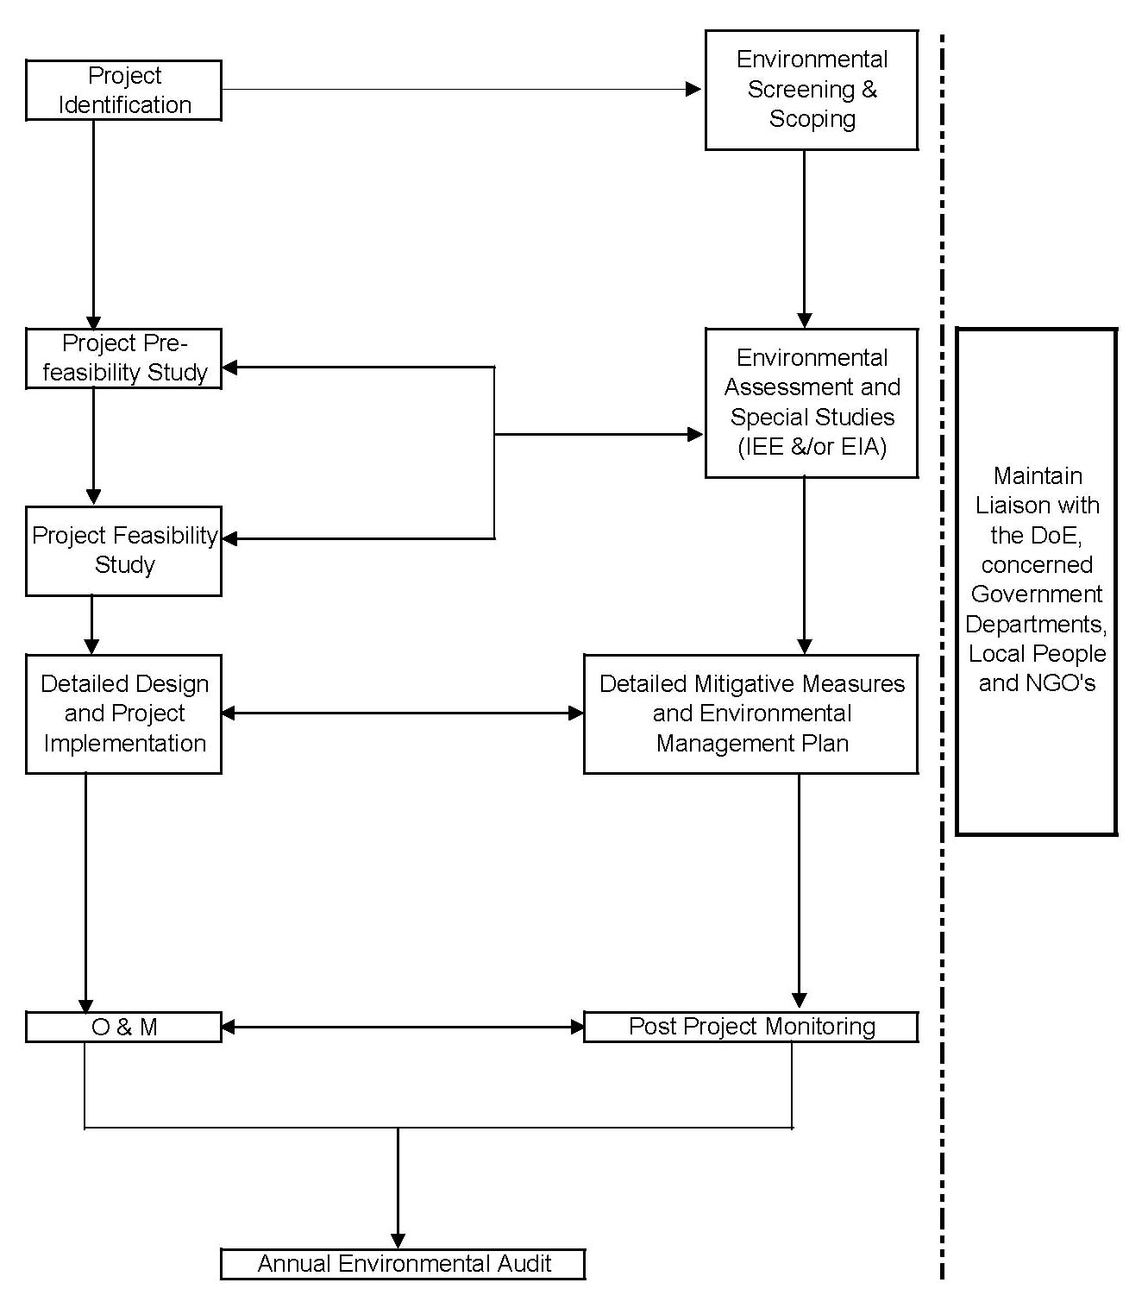

Environmental Assessment Guidelines
In Bangladesh it is mandatory to carryout Environmental Assessment for any development projects particularly at Feasibility Study Level. The environmental conservation/protection has to be carried out based on the legislation and plans prepared by the Government of Bangladesh. According to the EIA Guidelines of DoE and Environmental Source Book of World Bank (WB) the issues - Urban Water Supply and Sanitation and Resettlement issues falls under Red Category or Category A of WB or E1 in DWASA. The DS (Dhaka Sanitation) sub-projects are all related to urban water supply and sanitation issues of the Dhaka City.

In recent years environmental management has become a higher priority in GoB’s agenda due to the growing population, abstraction of natural resources, rapid industrialization and urbanization. The government of Bangladesh has developed a detailed policy framework which has been described in Section 2 in this report. Procedure and guidelines for different categories of the projects are stated as under:

Application for Environmental Clearance – E3 (Green) Category
Application for the environmental clearance for industries and other projects listed under category E3 (Green) need to accompany the followings :

- General information pertaining to the industry or project;
- Description of the product along with that of the raw material; and
- No objection certification (NOC) from the local authority.

Application for Environmental Clearance – E2 (Amber B & A) Category
Application for the environmental clearance for industries and other projects listed under category E2 (Amber B & A) need to accompany the followings :

- General information pertaining to the industry or project;
- Description of the product along with that of the raw materials;
- The process flow diagram;
- The layout plan (indicating the site for effluent treatment plant);
- Waste disposal system;
- Outlines of relocation, rehabilitation plan (where applicable);
- Other relevant information (where applicable);
- Feasibility Study Report of the industry or project (applicable only for proposed industries or projects);
- Initial Environmental Examination (IEE) Report with the process flow diagram, layout plan (indicating the site for effluent treatment plant), design of the effluent treatment plant (applicable only for proposed industries or projects);
- Environment Management Plan with process-flow diagram, layout plan (indicating the location of effluent treatment plant), design and efficiency of the effluent treatment plant (applicable only for existing industries or projects);
- No-objection certificate (NOC) from the local authority;
- Contingency plan in respect of adverse environmental impacts together with plan to reduce pollution load;
- Outlines of relocation, rehabilitation plan (where applicable); and
- Other relevant information.

Application for Environmental Clearance – E1 (Red) Category
Application for the environmental clearance for industries and other projects listed under category E1 (Red) need to accompany the followings :

- Feasibility Study Report of the industry or Project (applicable only for proposed industries or projects);
- Initial Environmental Examination (IEE) Report together with the terms of reference of Environmental Impact Assessment (EIA). and the process-flow diagram of the industry or project, or, the Environmental Impact Assessment (EIA) Report prepared on the basis of terms of reference approved earlier by the Department of Environment, layout plan (indicating the site for effluent treatment plant), design and time-schedule to construct the effluent treatment plant, process-flow diagram (applicable only for proposed industries or projects);
- Environment Management Plan (EMP) together with process-flow diagram, layout plan (indicating location of effluent treatment plant), design and efficiency of he effluent treatment plant (applicable only for existing industries or projects);
- No-objection-certificate (NOC) from the local authority;
- Contingency plan in respect of adverse environmental impacts together with plan to reduce pollution load;
- Outlines of relocation, rehabilitation plan (where applicable); and
- Other relevant information.

Necessity for EIA
Installation/replacement/expansion of water supply and sanitation projects are classified under “Red” category according to the EIA guidelines of the Department of Environment. All industries and projects listed in “Red” category are required to carryout IEE and subsequent EIA. In order to fulfill the requirement of DoE, it is required to conduct EIA, which should include the following:

- Identification of impacts of the project activities, both during construction and operational stages, on the various environmental components and recognizes those which are critical to the changes.

- Prediction of the environmental impacts using qualitative and if possible, quantitative methods.

- Recommendation of EMP to reduce adverse environmental impacts and enhance positive contributions of the project

- Presentation of the results of environmental impact identification, prediction and assessment, with suggested mitigative measures.

- To set the basis for continuous monitoring of key project activities and environmental conditions.

General Procedure for EIA
EIA is generally conducted in tiers. These tiers are identified in terms of the level of details necessary to appraise a project from the environmental angle so that a decision to implement a project or otherwise can be taken at the earliest, before significant efforts and funds are committed for implementation of the project.

In Bangladesh the EIA procedure will pass through three tiers in order to optimize the resources required for conducting EIA studies. These tiers are:

- Screening;
- Initial Environmental Examination (lEE); and
- Detailed EIA

Screening decides whether the EIA process should be applied to a development project and if it is required, it’s type i.e. lEE &/or EIA or limited EIA.

Environmental Clearance
In order to obtain environmental clearance from DoE, proponent must undertake a number of steps. The procedures for individual projects vary depending on its classification. Proposed developments would fall under three categories E3 (Green), E2 (Amber B & A) & E1 (Red). The Dhaka Sanitation (DS) projects the following steps should be undertaken. Steps in flow diagram are shown in Figure 4.
Figure 4 : Steps Leading to Grant of Environmental Clearance
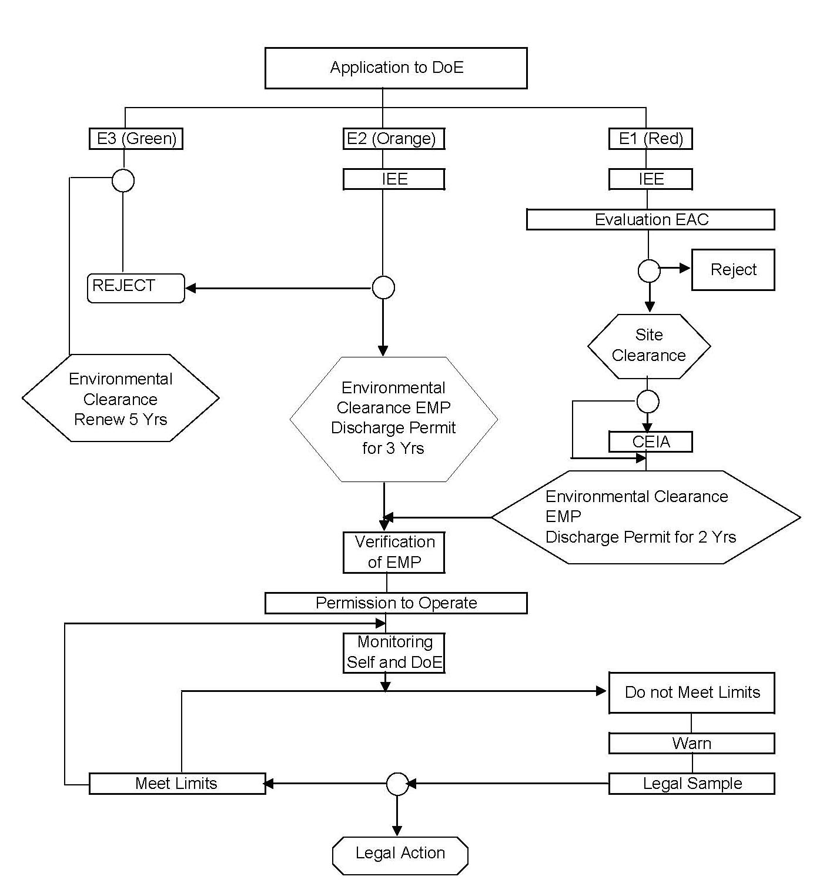

Environmental Impacts and Mitigation
It is intended that the Consultant shall evaluate environmental impacts of all works recommended for implementation and ensure that re-evaluation of environmental impacts is based on appropriate quantitative and qualitative analyses and comprehensive in their coverage. The preliminary identification of the physical works involved is classified as follows:

- Construction / Rehabilitation of Sewer Networks
- Construction / Rehabilitation of Storm Water Drainage Networks
- Collection System;
- Treatment Works;
- Disposal of Wastes;
- Sludge Management;
- Resettlement Issues of Different Canals; and
- WSS Programme to low income communities

The main Components of the physical works involved (DS 1A to DS 10) are listed below:

Table 4 : Main Components of DS & Associated Works

Sl. | ID # | Major Components of Associated Works
1 | DS – 1A | - Master Plan for Wastewater Management  - Detailed design & preparation of bidding documents for some urgent rehabilitation, strengthening and expansion of sewer network
2 | DS – 2 | - Feasibility Study of a CETP at Tejgaon;  - Feasibility Study of a Wetland;  - Construction of Collection Network System (Including Pump Stations);  - Construction of CETP at Tejgaon;  - Construction of Wetland;  - Rationalization of Sludge collection, disposal and safe disposal arrangement.
3 | DS – 3 | - Installation of Pumping Stations at Rampura and Kamalapur  - Development of drainage canals
4 | DS – 4 | Resettlement Action Plan involving detailed census including socio-economic data and an inventory of affected assets of the would-be displaced communities from the canals.
5 | DS – 5 | Environmental Management Framework
6 | DS – 6 | DWASA Performance Improvement Programme
7 | DS – 7 | WSS Program for low income communities to provide:  - Water Supply,  - Sanitation,  - Drainage,  - Solid Waste,  - Community facility, etc.
8 | DS – 8 | Tracer Study
9 | DS – 9 | Social Safeguard Issues. Recovery of some additional five to six canals involving survey for resettlement issues.
10 | DS – 10 | - detailed design of storm water drainage of around 34.39 Km

Magnitudes of Impacts as per E1, E2 & E3 Classifications
Outline of different categories of E1, E2 & E3 with respect to DoE and the World Bank’s category are compared as under :

Table 5: Delineate E1, E2 and E3 with DOE and World Bank context:

Sl No. | DWASA | DoE | World Bank | Descriptions
1 | E1 | Red | Category A | If a project is likely to have adverse environmental impacts that are sensitive will be in this category. A potential impact is considered sensitive if it may be irreversible, affect vulnerable groups or racial minorities, involve voluntary displacement and resettlement, or affect significant cultural heritage sites, diverse, or unprecedented. The project sponsor is responsible for preparing a full report, normally an EIA and for preparing and updating an EAP.
2 | E2 | Orange B & A | Category B | If a project involves potential adverse environmental impacts on human populations or environmentally important areas including wetlands, forests, grasslands and other natural habitats are less adverse than those of E1category projects. The impacts are site specific; few if any of them are irreversible and in most cases mitigation measures can be designed more readily than for E1 category projects. The scope of EA for this category project may vary from project to project, but it is narrower than that of EA for E1 category, limited EA is needed.
3 | E3 | Green | Category C | A proposed project is classified as this category if it is likely to have minimal or no adverse environmental impacts. Beyond screening, no further EA action is required for this category.

Environmental Assessment and Management Tools

Introduction
Environmental Assessments (EA) is both reactive and proactive - they are intended to predict the impacts of proposed project interventions and to ensure that environmental requirements are included in project planning. The aim is to identify all the significant negative impacts of a project and to provide recommendations for their avoidance or mitigation, whilst also providing equivalent recommendations on possible enhancement of environmental benefits. The costs of these recommendations and the other implications for implementation - such as organisational and institutional requirements also need to be assessed, in forms that can be readily used in the overall project design, financial & economic analysis. The characterisation of any residual and cumulative impacts is vital.

The objective of EA is not to disrupt or impede development, but to improve projects by ensuring that they are planned, constructed and operated in an environmentally sound manner. Unless there are other overriding considerations (e.g. protection of human life), projects should have no significant negative effects on the functioning of essential environmental processes - including the long-term sustainability of ecological resources and human well-being.

An EA should therefore:

- Describe the likely environmental conditions if the proposed project was not implemented;
- Assess the impacts of the proposed project if no environmental management measures were included;
- Specify and cost the environmental measures needed to improve the beneficial impacts and reduce or eliminate the adverse impacts;
- Ensure that these are included in an EMP to guide future project development stages.

Strategic Environmental Assessment
Strategic Environmental Assessment (SEA) is a relatively new concept. It involves the application of environmental assessment (EA) principles to take decisions at planning and policy levels, rather than taking decisions on specific projects. There is no internationally agreed definition of SEA. Far more so than in EIA, the term strategic encompasses a range of types and contexts of decision-making.

SEA describes a systematic process for evaluating and anticipating the consequences of decisions taken prior to the project stage. Its purpose is to ensure that environmental consideration and alternatives are addressed as early as possible and on a par with economic and social factors in policy, plan or programme development. SEA is therefore a decision-aiding rather than a decision-making process. Like the policies, plans and programmes to which it applies, SEA can be considered as a tool for forward planning.

The core definition of SEA reflects the basic principles of EIA as shown below.
“SEA is a systematic process for evaluating the environmental consequences of proposed policy, plan or program initiatives in order to ensure they are fully included and appropriately addressed at the earliest appropriate stage of decision-making on par with economic and social considerations”

The benefits of SEA:

- Helps in identifying conflicting objectives within policies, plans and programs.
- Assign responsibilities for environmental protection to various agencies.
- Allows meaningful consideration of alternative projects.
- Provides analysis of cumulative impacts of multiple developments.

The EIA process is conventionally applied at a project level and represents a limited response to those issues at higher levels of policy making. The following table provides a comparison between EIA and SEA.

Table 6 : Comparison between EIA and SEA

EIA | SEA
Deals with a specific project. | Deals with area, region or sectors of development.
Is reactive to a development proposal | Is pro-active and informs policies, plans and programme
Analyses direct +ve & -ve impacts and benefits. | Analyses cumulative impacts, identifies implications and issues for sustainable development.
Analyses the effect of a proposed development on the environment. | Analyses the effect of the environment on development needs and opportunities.
Concentrates on the mitigation and prevention of impacts. | Concentrates on sustaining & maintaining a chosen level of environmental quality.
Has a well defined beginning and end. | Is a continuous process aimed at providing information at the right time.
Narrow perspective and a high level of detail | Wide perspective and low level of detail

SEA may be incorporated into Water Supply and Sewerage Sector Planning because it is organised on a hierarchical structure. This would be beneficial because SEA would provide baseline information and allow priority projects. DWASA deals with only water supply, sewerage and drainage projects and is not mandated to take decisions at policy, planning and programme levels considering the environmental effects of water sector as a whole. This section has been provided here to understand the SEA concepts that will allow having a concrete realisation of the difference between SEA and EIA.

Internationally, most SEA experience tends to have been at the level of programmes and plans, where EIA Procedures and approaches can be applied fairly readily. SEA can be seen as an extension of EIA to facilitate strategic decisions.

The following key elements are essential components of SEA ;

Identification of broad policy, plan and programme alternatives;
Screening;
Scoping;
Scope of Environmental Analysis;
Development of guidelines for sustainability;
Assessment and adjustment of the policies, plan or programme;
Development of a management strategy for the implementation, monitoring and auditing of the policy, plan or programme. A generic SEA process diagram is reflected in Figure # 5.
Figure 5 : Generic SEA Process Diagram

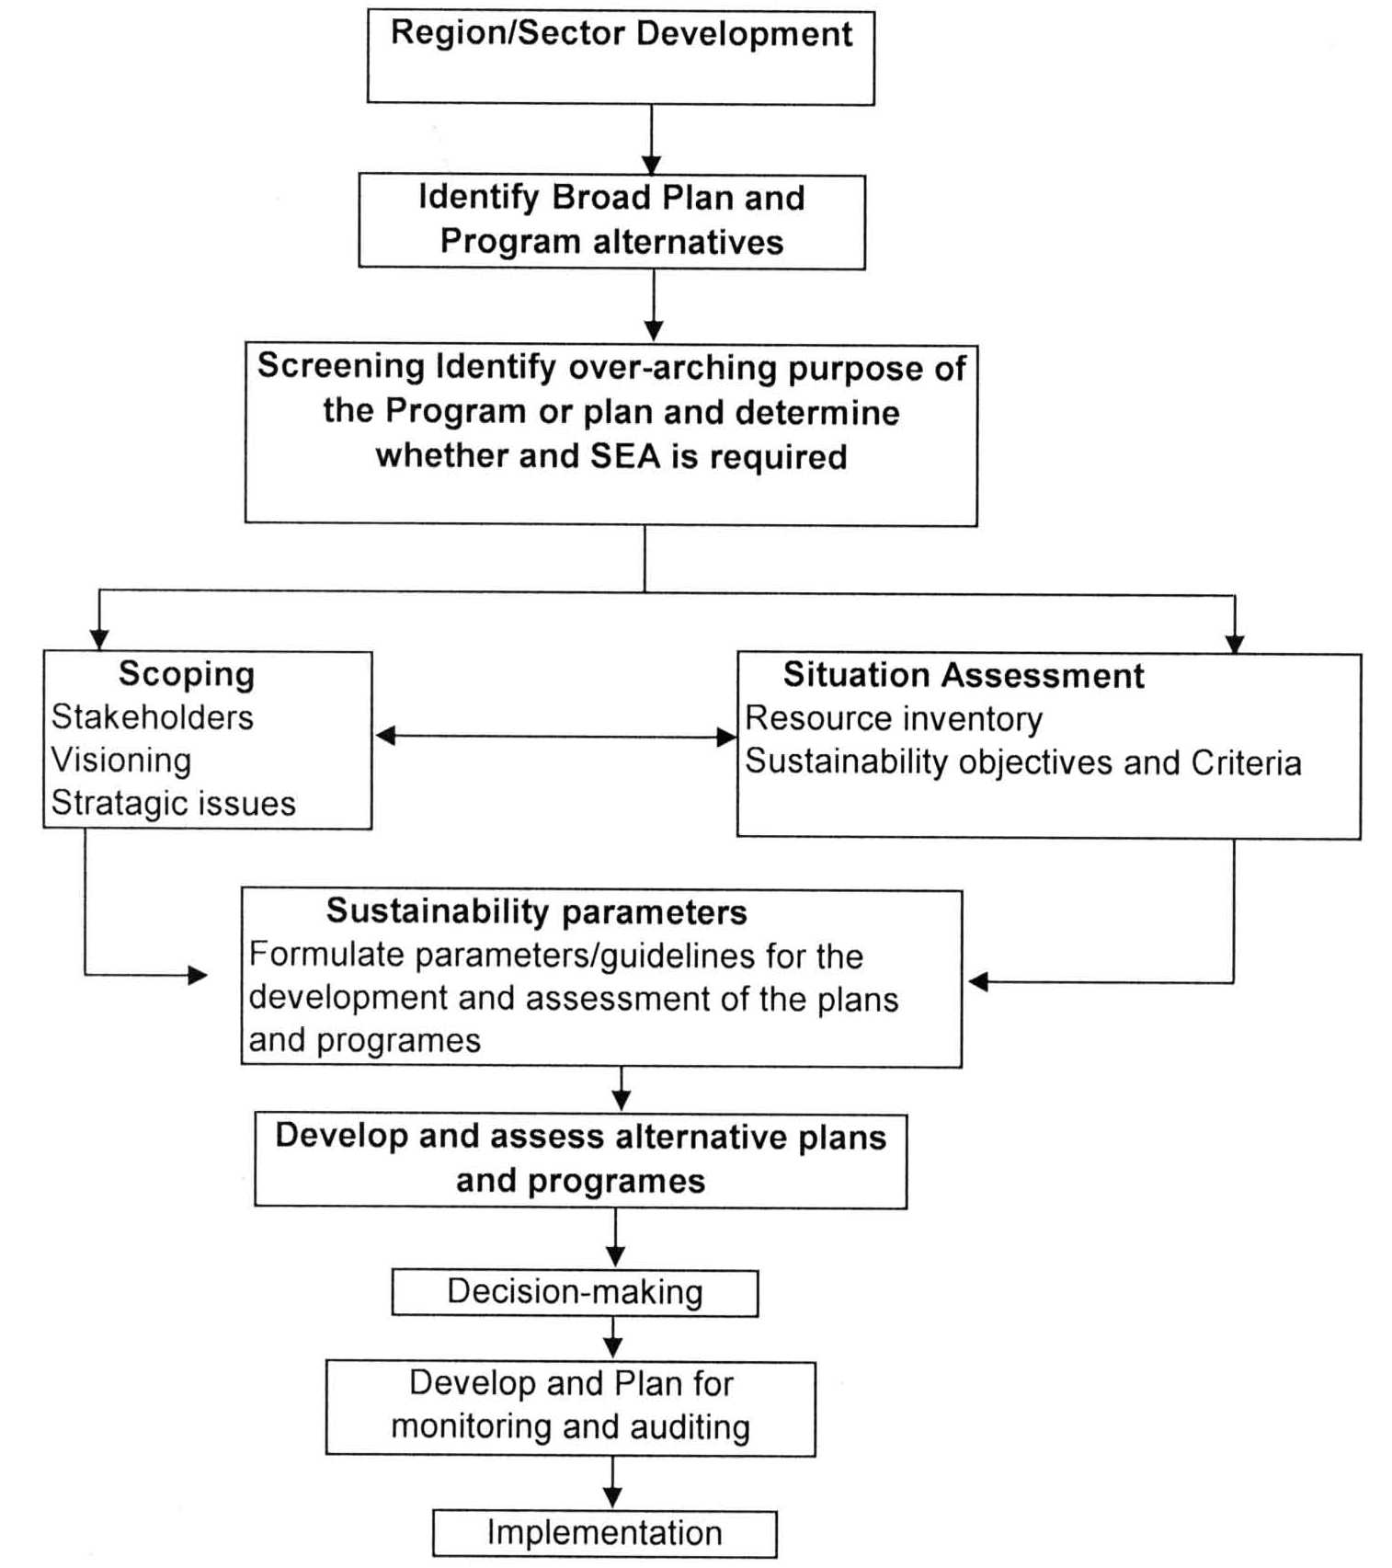

Environmental Impact Assessment

Environmental Impact Assessment (EIA) is an essential stage in assessment of all Red category projects as part of the DoE environmental clearance procedure. For Water Supply and Sanitation projects, EIA is the second, and main, level of assessment, applied at the project feasibility planning stage. The EIA studies in greater detail the impacts of a sanitation and drainage project design (although there may be some alternatives). The main objective at this stage is to make a quantified assessment of beneficial and adverse impacts a part of the basis for project costs and decisions.

For some important Environmental Components, the baseline survey requires observations over a whole season or cycle (e.g. water quality and fish migration). Where project time constraints prevent this, a note must be added to the report and recommendation made on the extra observations needed.

An EIA report is a significantly longer and more detailed document than an IEE report. It sets out the main features of the environment that are likely to be affected by the sewerage and drainage project, assessing the impacts (in quantitative terms wherever possible) on the physical, biological and socio-economic environments. The recommendations for future development should set out the requirements for environmental management and monitoring. The recommendations must be sufficient for the EIA reviewer to take one of four decisions:

- Reject the EIA as inadequate for the proposed project (or certain parts of it) and, therefore, to request improved assessment of specific item(s) in the report;
- Accept the EIA as an adequate basis to proceed to detailed project design and subsequent implementation of the project as planned, subject to the provisions in the EMP - modified, if necessary;
- Accept the EIA as an adequate basis to proceed to detailed project design and subsequent implementation, but with modifications of the design or implementation proposals to avoid or reduce adverse impacts. The modifications to be subject to a revised EIA and EMP;
- Reject the project because the nature and/or magnitude of the adverse impacts are technically, environmentally, socially and/or economically unacceptable.

All EAs – whether IEEs or EIAs - should proceed through the following steps:

- Review of Project Proposals and Alternatives
- Background Data Collection and Baseline Description
- People’s Participation
- Scoping and Bounding
- Impact Assessment

The primary purpose of conducting an EIA is to ensure that the environmental effects of proposed activities are adequately and appropriately considered before decisions are taken. These should serve as a key aid in the decision-making process by providing comprehensive information on the environmental consequences of development. Evaluated information and supporting arguments enable decision makers to evaluate the overall impacts of a proposal and alternatives to that proposal. EIA on the Project Lifecycle of DWASA is shown in Figure # 6.

Figure 6 : EIA in Project Lifecycle of DWASA
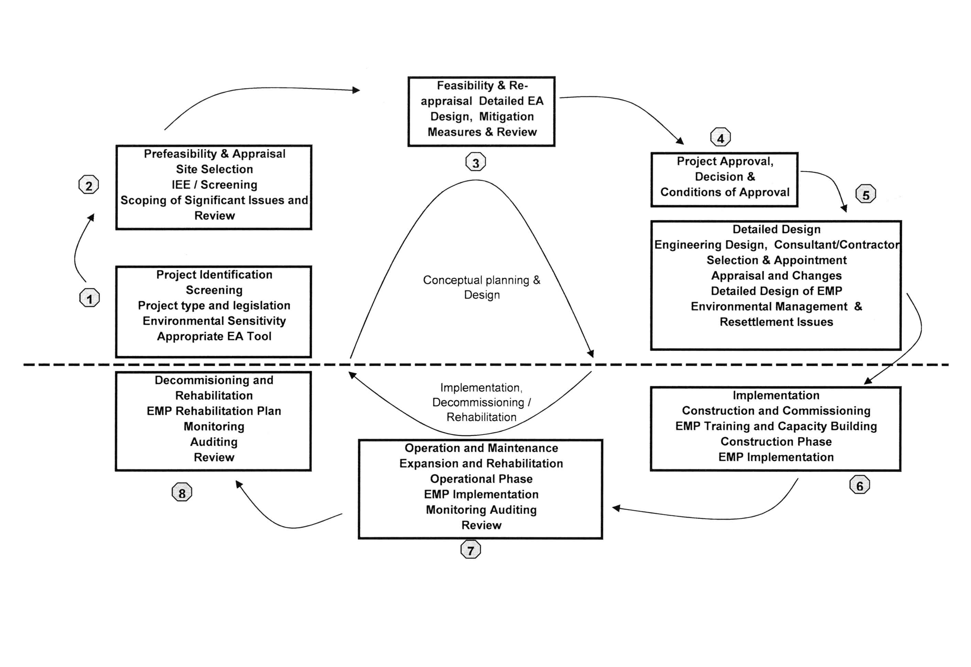

Environmental Management Plan (EMP)
An Environmental Management Plan (EMP) should be drawn up as part of the EA at both IEE and EIA stages, to deal with follow-up activities during subsequent stages of project development such as, detailed design, construction, implementation, operation, maintenance and decommissioning. The level of detail in the EMP will vary according to the stage of project study and development:

(a) For IEEs - identification of broad management requirements and constraints;
(b) For EIAs - identification of specific management activities, staffing (including training needs) and schedules;

The main contents of an EMP are:

- Mitigation and enhancement measures;
- Compensation arrangements;
- Environmental protection and monitoring activities;
- Peoples’ participation;
- Disaster management (contingency planning);
- Organisational and institutional arrangements;
- Responsibility and reporting framework;
- Cost estimates for all environmental management activities – including mitigation and enhancement measures.

The EMP should be developed with full people's participation, with the aim of achieving consensus between the EA practitioners, DWASA, other agencies (RAJUK, DCC), NGOs and local communities.

Environmental Assessment and Management Tools
The environmental improvements have been necessitated out of identified positive and negative aspects of the process, which are listed below :

Table 7 : Positive and Negative aspects of Environmental Assessment

Positive Environmental Assessment | Negative Assessment
- Facilities more informed decision –making to include environmental issues  - Assists in the selection of alternatives and influences project selection and design  - Directs content of formal approvals  - Predicts adverse effects | - Inconsistent application locally, nationally and internationally  - Operates as “stand alone” process and does not recognize the existence of other tools  - Weak follow-up following project implementation  - Cumulative effects are not properly addressed  - Limited or poor public consultation  - Voluminous descriptive reports that do not assess impacts adequately  - Insufficient process which is considered to be time consuming and costly

In addition to the above, it has been recognized that environmental issues should be considered in the planning and policy formulation process and that EA as currently constituted could not meet these requirements. The alternative environmental assessment and management tools should be implemented dependant on situational requirements. The Decision-making and Environmental Assessment and Management Tool is shown in the Figure # 7
Figure 7 : Steps of Environmental Assessment and Management Tools

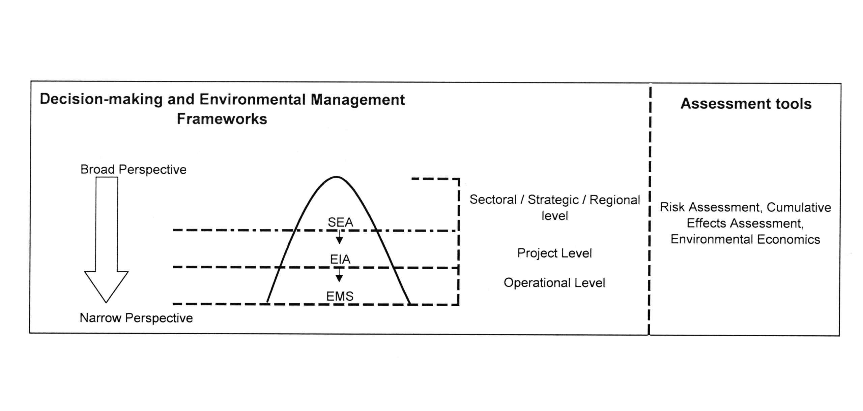

Environmental Monitoring Mechanism
Environmental monitoring recommendations are an essential part of the EMP. In the context of Sanitation and Drainage projects, the monitoring activities should run through the construction, implementation and decommissioning stages of projects.

The objectives are to:

- Measure the extent and benefit/severity of environmental impacts;
- Ensure early detection of unexpected impacts and development of measures to deal with them;
- Determine the efficacy of mitigation/enhancement measures to reducing/ improve impacts and to allow periodic review and adjustment of mitigation/ enhancement programmes;
- Describe the proposed sampling programmes, including the parameters to be measured; sampling strategies; frequencies, locations and times of sampling; personnel and equipment requirements and estimated costs.
- Provide indications on assessment of the monitoring data and how this will be utilised technically and procedurally to improve mitigation and environmental management;
- Indicate institutional responsibilities for the monitoring, outlining equipment, facilities, personnel and training needs.

EMP and Monitoring
In order to implement the EMP it will need an organizational set-up consisting of expert professionals, support staffs and logistics. Fortunately DWASA has at present an Environmental Cell which can look after the EMP and monitoring Activities.

There are other aspects of the EMP and monitoring issues where DWASA will be directly involved because the project has to be taken over by DWASA for its implementation, operation and maintenance. The O&M is a key issue which has to be reviewed whether DWASA has the institutional capability. As such in order to strengthen the institutional capability, it is required to review and assess the existing strength and future requirement of the O&M staffs.

Thus, it is important that expert professionals are provided from the very beginning at different stages of implementation such as;

- Pre-construction stage
- Construction stage
- Post construction stage

Besides the preparation of practical implementation plan, monitoring is the essential activity for deciding the effective and appropriate measures. The anticipated implementation plan and the monitoring plans at the respective stages of project implementations are described below:

This exercise is an example- the action plan will vary for the project specific cases.

1. Pre-construction Stage

Implementation Plan

Land Acquisition:

The issue of selection of the land will depend upon specific cases. After selection of the land the particulars of the land shall be prepared by DWASA for sending it to the DC’s office for acquisition of the land (where appropriate).

Monitoring

The issue needs constant liaison with DC’s office because ultimately all clearance has to be obtained for processing of the land from the above mentioned office. On receipt of the total value of the land for giving compensation to the PAP the money has to be deposited by DWASA to the Govt. treasury.

2. Construction Stage:

Implementation

Traffic, Waste Disposal, Noise/Vibration

Traffic:

This issue is management of highway traffic congestion during construction of the PS, CETP and Sewer / Drainage pipelines. It is considered as a major issue and shall be incorporated in the terms and conditions of the executing contractor. The very contractual document shall cover the mitigation measures followed by the management plan.

Waste Disposal:

A substantial quantity of soil is expected to be generated during the construction work and it is the joint responsibility of the executive authority and the contractor to ensure how best these are disposed off with some economic benefits. The contract agreement should provide necessary terms and conditions for dealing these issues so that the issue DoEs not create environmental problem rather should produce some economic benefits.
Noise & Vibration:

Noise produced by various mechanical/electrical equipments and other activities during the construction work is a major source of noise/vibration problem. As such machinery selection should be proper so that they produce less noise and vibration. Besides there are noise control devices which can be adapted with the machinery and night shift work with such machine producing high pitch sound shall be avoided.

Safety of other Utility Services :

There are several utility services network buried under road surface even on the road surface all over the Dhaka City. These utility networks carry importance as they require to be kept safe and undisturbed during the construction stage for the new services or facilities to be installed / rehabilitated along the road alignment.

Monitoring

Traffic:

i) Prepare daily/weekly plan and communicate to DMP/DCC respectively
ii) Arrange necessary campaign / prior information in case of closure of any route and also inform alternative route (if any)
iii) Ensure that necessary traffic signs / signals are available
iv) Workmen are provided with identifiable uniform
    - Maintain log book and submit daily report for any unusual situation and action taken to ameliorate traffic congestion.

Waste Disposal:

- Make available inventory of data/maps on section wise map route
- Daily record of progress of work in prescribed log book
- Daily log book to be checked by the representative of PD
- Make available walkie – talkie / mobile phones or similar device to site in charge / site engineer to monitor urgent decisions

Noise & Vibration
  - Ask Contractor to use comparatively less noisy machine & possible use of noise control device.
  - Avoid noisy machineries during night shift.

Safety of other Utility Services :
- Before excavation of any road trial pit may be executed to identify all underground utility services,
- Metal detector may be used to detect all metal utility services with its depth,
- As-built drawings of the respective organizations may be collected to identify the utility services,
- All precautionary measures are to be taken for the safety of the utility services of other organizations,
- In case of shifting of any utility services, permission to be obtained from the respective organizations

3. O & M

Implementation

Water Right , Waste Disposal, River Environment, Water Pollution, Noise & Vibration,

Water Right
Besides public body there private users for irrigation and other purpose, those who use the water of natural canals.
Also the river is used for navigation purposes. As such the issue of beneficial use of the natural resource shall be protected.

Waste Disposal
The issue of waste disposal should not create any problem for the natural water bodies. Besides this there is possibility of polluting the surface water due to unsatisfactory operation of the ETP.

River Environment
This issue is very much related to the issue of vested water right. The River is a natural resource & the ecology of the river shall be maintained.

Water Pollution
This issue is the same issue as that of waste disposal issue mentioned above.

Noise & Vibration
Noise & vibration produced by the mechanical / electrical equipments inside the pump station &/or during construction stage shall be maintained at a reasonable level by selecting quality equipments & by using various sound / vibration dampening methods. RCC foundation shall be designed in such a way that the vibration of the equipment is kept at a minimum level.

Monitoring

Water Right , Waste Disposal , River Env., Water pollution, Noise & Vibration

Water Right

The DWASA Env. Cell shall keep close watch if any individual/ group are violating the issue as prescribed in the National water policy. Any violation shall be reported to the concerned authority and action to be taken.

Waste Disposal
Maintain daily record

River Environment
The issue / action to be taken are same as that of water right.

Water Pollution
The issue / action to be taken are same as that of water right.

Noise & Vibration
A periodic check shall be conducted inside the pumping stations & compare with the allowable limit as prescribed by DoE.

Risk Assessment
Risk assessment is the process or method of determining an activity either man-made or natural which will negatively impact human being or their surrounding physical environment. Risk assessment recognises that forecasting project impacts is an uncertain business. It incorporates, in probabilistic statements of future conditions, specialists' best knowledge and predictions and historical data about the extent of uncertainty. Environmental Risk Assessment (ERA) is the process of evaluating the likelihood of adverse effects in the ecosystem from hazards that accompany human activities or their surrounding physical environment. In DWASA, risk assessment should be considered as part of the engineering design of projects, for example, as part of structural, reliability, or safety analysis.

In the environmental management arena there are two focus areas for risk assessment, which are :

- Human health and
- Ecological risk assessment

Human Health Risk Assessment

Human Health Risk Assessment (HHRA) is a qualitative or quantitative process conducted to characterise the nature and the magnitude of risk to public health from exposure to hazardous substances released from specific sites. HHRA is one of the three environmental health linkage methods available. It is predictive in nature and uses existing exposure data to quantify health effects of exposure to certain substances. Validated epidemiological and toxicological data are used to estimate potential health effects.

The HHRA process that has been defined by the United State Environmental Protection Agency (US-EPA), consists of four key components, which are used to characterise the risk of potential pollutants or hazards to human health, are :

Hazard Identification,
Exposure Assessment,
Dose-response Assessment, and
Risk Characterisation.

Environmental Risk Assessment (ERA) is an extension of an EIA, as the predictive power of EIA is limited dealing with uncertainties relating to environmental risk. ERA is undertaken when uncertainties are large and important to project success. Uncertainties usually arise from the following:

- Lack of theory and basic understanding;
- Inadequate environmental data on the project area, study area and impact area;
- Sampling and analytical error;
- Inadequate monitoring parameters;
- Lack of mitigation support;
- New technology, materials, sitting;
- Lack of long-term vision of the project.

Ecological Risk Assessment
Ecological Risk Assessment is defined as the practice of determining the nature and likelihood of effects of our actions on animals, plants and environment. Ecological risk assessments deal with human-caused changes that alter important features of ecological systems such as lakes, streams, forests, or water bodies. For example use of chemicals/pesticides in the crops there are possibility of damaging other plants and animals, etc. Economical risk may be local, regional or global and may involve a specific type of plant or animal, a community organism i.e. the fish in a lake, or an ecosystem i.e. biological and physical component of the lake or water bodies.

Ecological risk assessment helps organize information and contributes to take decisions. It is a useful management tool that :

- Highlights the greatest risks, which is helpful for allocating limited resources;
- Allows decision makers to ask “what if” questions regarding the consequences of various potential management actions;
- Facilitates clear identification of environmental values of concern; and
- Identifies critical knowledge gaps, thereby helping to priorities future research.

Ecological risk assessment can be used to evaluate the relative benefits of different clean-up options at hazardous waste sites, screen new chemicals prior to their commercial production, evaluate the risk that imported agricultural products may introduce foreign agricultural pests or determine the threats to valued ecological resources in a watershed. Ecological risk assessment is one input to environmental management decisions. Other inputs include stakeholder concerns, availability of technical solutions, benefits, equity, costs, legal mandates, and political issues. Within this context, an ERA should :

- Summarize results so that the public understand them;
- Distinguish scientific conclusions from policy judgment;
- Describe major differences of opinions on scientific issues or alternative conclusions that readers can draw from the data; and explain major assumptions and uncertainties.

The Environmental Risk Assessment (ERA) is presented diagrammatically in the form of Risk Assessment and shown in Figure # 8
Figure 8 : Environmental Risk Assessment Process
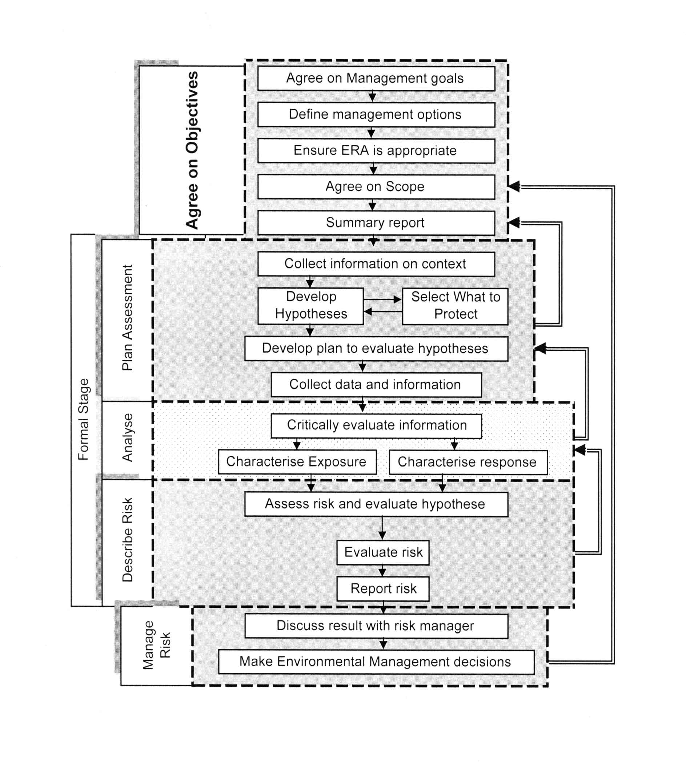

Gap Analysis

Introduction

The EMF of DWASA prepared under DS-5 has been prepared mainly to address and assess the upcoming sub-projects (DS – 1 to DS 10) that come on board under (IDA : PPF Study Project - Credit # Q 4780). Several gaps and weaknesses have so far been identified and these are broadly categorized into the following:

- EMF to cover Overall Activities of DWASA
- Legal Provisions
- Institutional Accountability
- Capacity and Training
- Resource Constraints
- Technical Issues
- Monitoring, Compliance & Awareness

EMF to cover Overall Activities of DWASA

During presentation of the Draft Final Report of the EMF, Package DS-5, held on the 20th September, 2007, Dr. Feroz Ahmed, honorable Vice-Chairman of DWASA Board, chaired the presentation session and concluded with specific comment that the World Bank may help DWASA to prepare the general EMF covering the overall activities of DWASA, as because the present EMF is confined to the sub-projects (DS-1 to DS10) only. The present EMF does not fulfill the expectation of the audience as because it does not cover the overall activities of DWASA, which is one of the main gaps and weaknesses of the present EMF that needs to be addressed in due course.

Legal Provisions

The present Policies, Acts, Rules & Regulations with respect to the Environmental issues are under the custodian of the Department of Environment (DoE). All these Policies, Acts, Rules & Regulations are old, which need to be updated to fulfill the present requirements. For example the Environmental Conservation Act, 1995 as amended, speaks about waste only in general, and the Environmental Conservation Rules, 1997, made under this Act, do not suggest any specific measures for regulation of wastes, treatment of wastes and sludge management, whereas this is one of the major activities of DWASA. Usually the environmental issues in the country are handled by different sectoral policies and legislation, such as land use, water and air pollution, toxic chemicals, noise, solid wastes, wildlife protection, forest conservation, environmental health and sanitation. The sectoral laws dealing with different environmental issues in Bangladesh were enacted at different periods. They were useful at the time they were enacted, but many not completely answer present development needs. Moreover, the environmental concerns and priorities of the country have changed considerably since the laws were passed. For environmental management in particular, updating of some laws is needed. Most of these Policies, Acts, Rules & Regulations deals with the industrial pollutions but are not specific to the activities of Dhaka WASA &/or other concerned department. In order to cover all activities of DWASA, we feel that the following Policies, Acts, Rules & Regulations need to be amended, for which initiative should be taken by the concerned organization (s):

- Environmental Conservation Rules, 1997,
- Environmental Conservation Act, 1995,
- Water Supply and Sewerage Authority Act, 1996,
- Groundwater Management Ordinance, 1985,
- Water Resource Act, 1992,
- Embankment and Drainage Act, 1952,
- Waste Land Manual, 1936,
- Agriculture and sanitary Improvement Act, 1920

The amendment of rules, regulations and laws are mostly beyond the jurisdiction of DWASA and may not be practical in the near future. In such a situation, DWASA may adopt internal procedures based on reasonable international good practice.

Table 8 : Environmental Issues and Relevant Laws and Regulations need revision
Issues | Laws/Regulations | Enforcing Agency | Upgrading/revision/comments
Surface water quality | - ECA, 1995  - ECR 1997  - Environmental Court Act, 2000  - National Policy for Safe Water Supply and Sanitation, 1998  - The Local Government Ordinance, 1983 | MOEF/DOE  MOEF/DOE  MOEF/DOE  MOLGRDC/ DPHE / UPs | - More detailed surface water quality standards including more parameters then in the Schedule-3 (ECR97) in view of chemical pollution in the Urban Water shed.  - Hydrologic Unit Code (HUC) based surface water quality specification for urban watershed management.
Water pollution | - ECA, 1995  - ECR 1997  - Environmental Court Act, 2000  - National Policy for Safe Water Supply and Sanitation, 1998  - The Local Government Ordinance, 1983 | MOEF/DOE  MOEF/DOE  MOEF/DOE  MOEF/DOE  MOLGRDC/ DPHE  Ups | - Revision of point source discharge standards (Schedule-9&10 of ECR97) including more parameters in view of changing characteristics of water pollution in urban watershed.  - Measures to limit cumulative discharge in the watershed by introducing explicit polluters pay principle in ECA95.
Sewerage discharge management | - ECA, 1995  - ECR 1997 | MOEF/DOE  MOEF/DOE | - Inclusion Sewerage Treatment Plants in the Industrial Emission Standards (i.e., Schedule-11 of ECR)  - Sewerage Sludge management protocol development.
Air Emissions | - ECA, 1995  - ECR 1997 (amended 2005)  - Environmental Court Act, 2000  - Brick Burning Control Act, 1989 (Amended 1992)  - Motor Vehicle Act, 1983 | MOEF/DOE  MOEF/DOE  MOEF/DOE  MOEF/DOE  MOEF/DOE  BRTA/Police | - Inclusion of common air pollutants forms Sewerage Treatment Plants in the standards for odour or in schedule-11 of ECR.
Toxic or hazardous waste pollution  Solid waste pollution | - ECA, 1995  - ECR 1997 | MOEF/DOE  MOEF/DOE | Inclusion of heavy metal concentrations in the solid waste disposal standard and mandatory disposal in sanitary landfill.  Canal digging may produce considerable solid waste with heavy metals in the near future (DS-10). As a cautionary measure the disposal sites may be recorded for future remedial action.

Institutional Accountability
As per prevailing legislations of the country, DoE is responsible, with limited delegation of power, to take action against the defaulters for the environmental degradations of natural canals, water bodies (both surface and groundwater), Peripheral River, etc. Unless and until power has been delegated, DWASA cannot take any action against the defaulters who is responsible for the environmental degradation of water bodies (both surface and groundwater), river pollution, discharging industrial wastes directly to the river without any treatment, etc. In order to monitor all sorts of environmental considerations limited to overall activities of DWASA, the Government has created Environmental Cell within DWASA, but many of the sanctioned posts of the Environmental Cell have been lying vacant for months together. The Environmental Cell of DWASA should be well equipped with all staffs and logistic facilities so that they can discharge their duties independently with due diligence. But as per approved Organogram there is no existence of the Environmental Cell, rather there is only Environmental Monitoring Division with 6 (six) staffs. Hence it is strongly recommended to amend the Organogram and the existing structure of the Environmental Cell Circle with two Divisions along with all sanctioned posts be filled up soon.

Within the WASA Act’ 1996, considerable power has been given to the DWASA Board despite that DWASA cannot take appropriate actions independently, because the first organogram of DWASA has not yet been approved by the Government (expecting approval soon).

Table 9 : Environmental Issues and Actions for better Institutional Accountability
Issues | Current Status | Actions
Environmental Monitoring Division | - As per present Organogram | - The Organogram needs to be amended and existing Environmental Cell Circle with two Divisions along with all sanctioned posts be filled up soon
Environment Cell | - Cell is run down with less than half the approved staff  - Functional Roles and responsibilities of the cell staff unclear | - Process is underway to approve a new staffing plan  - Clear functional roles and responsibilities for the staff may be defined through mapping for activities required for implementation of EMF.
Environment Cell Work Program | - Work program is not clearly defined  - Preparation of monitoring reports/Guidelines/manual not done regularly | - Yearly, periodic and non-periodic (demand based) work program and outputs for environment cell may be defined.  - Pre-specified reports may be produced  - Initiate operational procedure to field level staffs & job description of each staff according to works plan
Availability of Environmental information to the Public | - Dissemination of reports Guidelines/manuals on Environmental issues not available  - Regular Consultation Workshop(s) not held | - Such document may be put on  - Such consultation may be scheduled on a regular basis

Capacity and Training

Under the present EMF (DS-5) two manual have been prepared - one for the improvement and monitoring of the construction related environmental impacts and another manual in Bangla for creating awareness among the low income community. These manuals do not cover the overall activities of DWASA, which is considered another gap and weakness to be resolved in due course. For implementing the EMF the concerned personnel of DWASA should be trained properly both in class room and site seeing of well maintained water works, modern sewage treatment plant, sanitation facilities, improved environmental conditions, etc outside the country. Although DWASA has got one in-house training centre and trainings have been organized among the concerned personnel time to time on different subject, so far it is learned that no such training has been organized for the improvement of environmental impacts. It is strongly advised to include training programme quarterly, especially for the improvement & monitoring of the construction related environmental impacts and develop awareness campaign, for which budgetary provision should be kept so that local and overseas training can be arranged regularly. The Environmental Unit of DWASA should be competent enough to produce IEE for new projects; supervise the environmental works undertaken by the NGO & Consultants; monitoring the performance as well as the progress of environmental consultants; implementing recommendations of EIA on DWASA projects.

The objective of the environmental trainings is shortly described as under :

- To familiar with the environmental policies of the GoB, and its relevance to DWASA and also to familiar with the guidelines of major donors for protecting the environment,
- To understand the requirement of EMF, guidelines, monitoring & mitigation parameters, etc.
- To understand the term and its effects about EA, IEE, EIA and EMF, etc.
- To understand clearly the role of the Environmental Unit of DWASA
- To understand the term “Negative & Positive” Environmental Impacts.

Resource Constraints
Surface and groundwater resource management and monitoring its quality are the responsibility of DWASA. There are over 465 DTWs and about 2,500 Km of water pipelines and about 200,000 house connections within the jurisdiction of DWASA. But with the limited staffs of DWASA it is not always possible to collect water samples and conduct testing of samples regularly. Similarly the Environmental Cell of DWASA cannot monitor the environmental parameters due to their limited number of staffs and inadequate resources and mobilization of fund. Similarly, DWASA laboratory is also facing financial stringency within their limited budget and shortage of chemicals they cannot test the water quality samples regularly. Some times, DWASA is discharging the effluent from the Sewage Treatment Plant at Pagla to the Buriganga River without maintaining the standards of the effluent quality, as a result river water is reported to be polluted and aquatic animals cannot survive causing ecological risks.

Technical Issues
DWASA is a public service institution, operating on a commercial footing. It is mandated to carter to the water supply, sewerage and storm water drainage services to the dwellers of metropolitan Dhaka City and Narayanganj town through 7(seven) MODS Zones. Apart from its aforesaid major functions, its ordinance allowed it to produce pure bottled water to serve the people alongside similar bottled water producers. In all its efforts, DWASA remains fully aware of and responsive to the overall environmental requirements of its own domain and beyond.

DWASA is responsible to supply potable water to the City dwellers. But many of the distribution pipelines are old and unserviceable, which are causing frequent leakages. The system pressure is some time negative and due to intermittent water supply (some times by operating valves, one area is being supplied in and other area no supply), consequently, due to back pressure surrounding polluted water enters into the distribution pipelines and ultimately entered to the customer’s premises. Again in many cases the underground reservoirs and roof tanks of the customers are not cleaned properly and polluted water enters to the customer’s premises and some time these water samples are highlighted in the news paper blaming that DWASA is supplying dirty water to the customer without proper treatment.

DWASA is responsible for O&M of the Primary Storm water drainage system of Dhaka city, but the DCC is responsible for the O&M of the secondary and tertiary drainage system of the city. That means storm water drainage management is under the dual responsibility of both DCC and DWASA. But in case of any water logging in the city roads, DWASA may argue that DCC is responsible and whereas DCC may argue that DWASA is responsible. Similarly during construction of the underground piped drains, naturally roads are to cut and pipes are to install for which traffic movement is restricted causing traffic jam, but in many cases DWASA is being criticized by the media / news paper and termed DWASA as the road cutting agency.

DCC is responsible for collection, disposal and management of the Solid Wastes of Dhaka City, which is one of the major activities of environmental degradation and pollution within Dhaka City. But many of the storm water drains and sanitary sewers are blocked by the solid wastes dumped through the openings of manhole covers illegally; consequently, DWASA is being criticized by the media / news paper for not cleaning the drainage and sewers in time. Again during cleaning of these drains and sewers, the solid wastes are collected, removed and dumped outside the manhole by the road side, which is again become the responsibility of DCC for its removal and disposal. These are the common technical issues due to dual functions, which need to be resolved in due course.

Monitoring, Compliance and Awareness

Environmental monitoring, compliance of the regulations, Acts & Policies and awareness campaign will improve the environmental degradation upto certain standards. Willingness to improve the environmental degradation is a precondition. Unless there is a commitment from the heads of the organization as well as from the senior officials and all other employees of the organization, the environmental degradation cannot be improved at all even if there is nice Policies, Regulations, Requirements, etc.
Quality assurance and quality control (QAQC) are important issues in monitoring. Monitoring of necessity involves measurement of analytical parameters. The QAQC issues related to analytical procedures are given in table-10.
Table 10 : Quality Assurance and Quality Control in Analytical Procedures

Issues | Current Status | Actions
Good laboratory practices (GLP) | - Currently not implemented | - Normative GLP should be adopted and progressively implemented
Protocols for specific Analysis | - Currently analytical protocols are not specified | - Specific protocols for the analytical parameters should be adopted (e.g. USEPA Test Methods, Standard Methods of AWWA etc)
Standard operations procedures (SOP) | - SOPs are not available for equipment and procedures | - SOP should be written for all equipment and procedures by well qualified experts.
Availability of Certified Standards | - Limited availability of certified standards | - Stock of certified standards should be build-up so that all analytical results are traceable (e.g., NIST).
Analysts to be certified | - Currently analysts are not certified | - Certification from suitable authority should be implemented progressively
Participation in analytical inter-comparison exercises | - Currently rarely done | - Participation in national and international inter-comparison should be regular feature
Standardization of analytical reports and documentation | - Not all reports and documentation are done in a standard manner | - All documentation and reports should be standardized
Investment plan for equipment, spares, supplies and services | - Time bound fungible plan not available | - Time bound plan with appropriate resource allocation should be made

Checklist and Screening of Sub-Projects &/or new Projects

Development and Screening of Sub-Projects
Screening is a requirement for environmental assessment processes for non-listed activities. The screening process would form the same purpose as a “Preliminary Environmental Impact Assessment”. The purpose of screening is to differentiate those projects that may have detrimental effect on the environment with those where no impact is likely to occur. The screening phase of the EIA should decide the following :

- Need and level of assessment;
- Preliminary review of the potential environmental effects that could result from project to project;
- Necessary permits or approval processes;
- Potential for conflict as a result of the development;
- Public participation process;
- Total life-cycle of the project

The following parameter is identified to assist the proponent during the screening process. The checklist provides number of questions which when answered should give the proponent an idea of the potential impacts related to the proposed development. The following parameter is identified, which are:

- General Aspect,
- Landscape and visual characteristics,
- Air Quality and Atmospheric Conditions,
- Biological Resources,
- Hydrology and Water Quality,
- Land Use and Property Issues,
- Waste Generation,
- Agriculture Resources,
- Geology,
- Seismisity,
- Noise and Vibration,
- Stability,
- Hazard and Hazardous Materials,
- Erosion,
- Soil and Health Aspects,
- Traffic related Impacts,
- Historic and Cultural Features,
- Protected and Conservation Worthy Areas,
- Broader Considerations
- Other Issues

The Consultant have designed & improved a “Checklist for Environmental Parameters for Project Classification” as shown in Table 11 , which will be tested for all ongoing sub-projects of DWASA - DS 1A, DS 2, DS 3, DS 4, DS 5, DS 6, DS 7, DS 8, DS 9 & DS 10. This Checklist has been designed/programmed by using the user friendly software – Microsoft Excel in such a way that once the value is marked/tick (), it will generate the result automatically and the consultant is confident that it will be very useful tool (software) for DWASA. Based on the findings upon evaluation of the checklist, the individual classification of each Project / Sub-Projects whether it will fall under category E1, E2 & E3, will be evaluated in the following sections.
Table 11 : Blank Checklist for Environmental Parameters for Project Classification

Serial No. of Parameters | Environmental Impact Assessment (EIA) Parameters | Relative weight age (w_{i}) | NO or Insignificant impact | Positive Impact (v_{i}) | Negative Impact (v_{i}) |  |  |  |  | Graded value | Remarks (Qualitative)
 |  |  |  |  | Very low | Low | Moderate | High | Very high | w_{i}v_{i}
Serial No. of Parameters | Impact scale/rating/degree |  | 0 |  | -1 | -2 | -3 | -4 | -5 | w_{i}v_{i}
Serial No. of Parameters | Please tick the box for selecting scale  | a | b | c | d | e | f | g | h | i
A | Environmental Problems due to Project Location
1 | Resettlement | 4 |  |  |  |  |  |  |  | 0 | Social inequities
2 | Land Value Changes | 2 |  |  |  |  |  |  |  | 0 | Social inequities
3 | Pollution towards downstream communities | 4 |  |  |  |  |  |  |  | 0 | Pollution of downstream communities
4 | Water supply rights | 4 |  |  |  |  |  |  |  | 0 | Loss of water for other users in region
5 | Historical/Cultural monuments and values | 3 |  |  |  |  |  |  |  | 0 | Losses of these values
6 | Encroachment on precious ecological areas | 3 |  |  |  |  |  |  |  | 0 | Loss of precious ecology
 | Sub total graded value (∑. w_{i}v_{i} ) |  |  |  |  |  |  |  |  | 0
 | Absolute Grade Value |  |  |  |  |  |  |  |  | 0.00
 | Category Grade | E3 = 0 to 11% |  | E2 = 11.1 to 40% |  |  | E1 = 41.1 to 100% |  |  | 0%
B | Environmental Problems due to inadequate Design, including assumption relating to O&M
7 | Interference with other utilities in same trench | 2 |  |  |  |  |  |  |  | 0 | Interruption in services
8 | Loss of community recreational areas | 2 |  |  |  |  |  |  |  | 0 | Loss of recreational areas
9 | Traffic congestion and noise problems | 2 |  |  |  |  |  |  |  | 0 | Adverse effects on community, including losses in time, nuisances, health effects
10 | Intensification of water pollution control (from sewers) | 3 |  |  |  |  |  |  |  | 0 | Increase in pollution of waterways
11 | Creation of sewage/ sanitation problem (from WS) | 2 |  |  |  |  |  |  |  | 0 | Hazards to community health and aesthetics
12 | Inadequate attention/ services to poor people | 2 |  |  |  |  |  |  |  | 0 | Social inequities
13 | Slum formation hazards | 2 |  |  |  |  |  |  |  | 0 | Unnecessary increase in social problems
14 | Solid wastes problem intensification | 2 |  |  |  |  |  |  |  | 0 | Increased problems of community sanitation
15 | Drainage problem intensification | 3 |  |  |  |  |  |  |  | 0 | Increased storm flooding problems in community
16 | Inadequate Operation and Maintenance | 2 |  |  |  |  |  |  |  | 0 | Will lead to plothargy of environmental problems
17 | Hazardous materials spills | 3 |  |  |  |  |  |  |  | 0 | Hazards to workers and nearby residents
18 | Environmental aesthetic problems | 2 |  |  |  |  |  |  |  | 0 | Loss in community environmental aesthetics
19 | Water/ Sewer pipes cross connections | 3 |  |  |  |  |  |  |  | 0 | Health hazard if not property designed and constructed
 | Sub total graded value (∑. w_{i}v_{i} ) |  |  |  |  |  |  |  |  | 0
 | Absolute Grade Value |  |  |  |  |  |  |  |  | 0.00
 | Category Grade | E3 = 0 to 11% |  | E2 = 11.1 to 40% |  |  | E1 = 41.1 to 100% |  |  | 0%
C | Environmental Problems in Construction Stage
 | Hazards to workers (and nearby residents)
20 | (a) accidents, including fires and explosions | 2 |  |  |  |  |  |  |  | 0 | Injuries to health/ safety of workers/ nearby residents
21 | (b) hazardous materials/ contacts and spills | 2 |  |  |  |  |  |  |  | 0 | Injuries to health/ safety of workers/ nearby residents
22 | (c) communicable disease hazards | 2 |  |  |  |  |  |  |  | 0 | Injuries to health/ safety of workers/ nearby residents
23 | (d) emissions of dusts, fumes, noise & vibrations | 2 |  |  |  |  |  |  |  | 0 | Injuries to health/ safety of workers/ nearby residents
24 | Uncovered cut-and-fill areas | 2 |  |  |  |  |  |  |  | 0 | Soil erosion/ silt runoff and consequent damages to properties and aesthetics
25 | Local flooding during backfilling or washing operations | 3 |  |  |  |  |  |  |  | 0 | Local flooding damages
26 | Quarrying hazards | 2 |  |  |  |  |  |  |  | 0 | Hazards to safety of workers and others nearby
27 | Any leakage of large scale sanitation system | 3 |  |  |  |  |  |  |  | 0 | Ground water contamination
28 | Accidental damage to utilities in same trench | 3 |  |  |  |  |  |  |  | 0 | Loss of time and fuel and accidents
29 | Traffic congestion and blockage of access to buildings | 2 |  |  |  |  |  |  |  | 0 | Traffic congestion and blockage of access to buildings
30 | Inadequate backfilling and resurfacing | 3 |  |  |  |  |  |  |  | 0 | Implement of streets and other paved areas
31 | Construction monitoring deficiencies | 2 |  |  |  |  |  |  |  | 0 | Unnecessary damages to environment
32 | Inadequate danger signals, especially during night | 2 |  |  |  |  |  |  |  | 0 | Possible accidents
33 | Lack of proper watering to reduce dust | 2 |  |  |  |  |  |  |  | 0 | Dust and air pollution
34 | Lack of proper trench protection | 3 |  |  |  |  |  |  |  | 0 | Possible accidents and damage of roads
 | Sub total graded value (∑. w_{i}v_{i} ) |  |  |  |  |  |  |  |  | 0
 | Absolute Grade Value |  |  |  |  |  |  |  |  | 0.00
 | Category Grade | E3 = 0 to 11% |  | E2 = 11.1 to 40% |  |  | E1 = 41.1 to 100% |  |  | 0%
D | Environmental Problems in Operation Stage
35 | Occupational health inadequacies | 2 |  |  |  |  |  |  |  | 0 | Damage to workers health/ safety
36 | Inadequate O&M performance | 2 |  |  |  |  |  |  |  | 0 | Damage to workers health/ safety
37 | Nuisances/ Pollution/ health hazards due to inadequate O&M | 3 |  |  |  |  |  |  |  | 0 | Nuisances and damages to workers and neighbors and neighboring properties
38 | Monitoring deficiencies | 2 |  |  |  |  |  |  |  | 0 | Without monitoring poor O&M can be expected, same as above
 | Sub total graded value (∑. w_{i}v_{i} ) |  |  |  |  |  |  |  |  | 0
 | Absolute Grade Value |  |  |  |  |  |  |  |  | 0.00
 | Category Grade | E3 = 0 to 11% |  | E2 = 11.1 to 40% |  |  | E1 = 41.1 to 100% |  |  | 0%
E | Critical Overall Environmental Review Criteria
39 | Will the project cause unwarranted loses in precious/ irreplaceable natural or other resources? | 1 |  |  |  |  |  |  |  | 0 | No
40 | Will the project make unwarranted accelerated use of scarce resources in favor of short-term over long-term economic needs? | 1 |  |  |  |  |  |  |  | 0 | No
41 | Will the project adversely depreciate the national energy/ foreign exchange situation to an unwarranted degree? | 1 |  |  |  |  |  |  |  | 0 | No
42 | Will the project result in unwarranted hazards to endangered species? | 1 |  |  |  |  |  |  |  | 0 | No
43 | Will the project tend to intensify undesirable migration from rural to urban sectors to an unwarranted degree? | 1 |  |  |  |  |  |  |  | 0 | No
44 | Will the project tend to increase the “Income gap” between the poor and affluent sectors? | 1 |  |  |  |  |  |  |  | 0 | No
 | Sub total graded value (∑. w_{i}v_{i} ) |  |  |  |  |  |  |  |  | 0.00
 | Absolute Grade Value |  |  |  |  |  |  |  |  | 0.00
 | Category Grade | E3 = 0 to 11% |  | E2 = 11.1 to 40% |  |  | E1 = 41.1 to 100% |  |  | 0%
 | Recommendation | Category Grade |  |  | 0.00% | DWASA Subproject Category |  |  |  | E3

 |  |  |  |  |  |  | SUMMARY EVALUATION
Sector | Relative weightage (w_{t}) |  |  |  | Maximum Grade (w_{t}v_{max.}) |  | $\sum{\text{WiVi}}$Absolute Grade Value |  | $\left\{(\sum{W}iVi)/WtV\text{max}\text{.}\right\}∗\text{100}$Graded Value(%) V_{G} = |  |  | $\left\{\sum{(}V\text{Gi}W\text{ti})/{\sum{W}}\text{ti}\right\}∗\text{100}$Valuation (%) V =
A | 20 |  |  |  | 100 |  | 0.00 |  | 0.00 |  |  | 0.00
B | 30 |  |  |  | 150 |  | 0.00 |  | 0.00
C | 35 |  |  |  | 175 |  | 0.00 |  | 0.00
D | 9 |  |  |  | 45 |  | 0.00 |  | 0.00
E | 6 |  |  |  | 30 |  | 0.00 |  | 0.00
  $\sum{W}\text{ti}=$100
 |  |  |  |  |  |  |  |  | CONCLUSION |  |  | E3
E1 = A detailed Environmental Assessment will be required |  |  |  |  |  |  |  |  |  | Graded Value for E1 = 41.1 to 100%
E2 = Limited Environmental Assessment will be required |  |  |  |  |  |  |  |  |  | Graded Value for E2 = 11.1 to 41%
E3 = No further study will be required |  |  |  |  |  |  |  |  |  | Graded Value for E3 = 0 to 11%
W_{t} = Total weightage for each sector
 |  |  |  |  |  |  |  |  |  | Recommendation for Sub-project
Vmax. = Maximum Impact Scale = 5 |  |  |  |  |  |  |  |  |  |  |  | E3

There are 5(five) major sectors / parameters, which are summarized with their respective weightage :

Table 12 : Summary Assumptions of the Checklist Form

Sector | Description | # of Items | Weightage | Maximum Grade
A | Environmental Problems due to Project Location | 6 | 20 | 100
B | Environmental Problems due to inadequate Design, including assumption related O&M | 13 | 30 | 150
C | Environmental Problems in Construction Stage | 15 | 35 | 175
D | Environmental Problems in Operation Stage | 10 | 9 | 45
E | Critical Overall Environmental Review Criteria | 6 | 6 | 30
 | Total : | 50 | 100 | 500

Note : Weightage for the respective sectors have been assumed on the basis of number of items in each sector and their importance in the environmental impact assessment. Besides Negative Impacts have been assumed for Very Low, Low, Moderate, High and Very high as -1, -2, -3, -4 & -5 , respectively. Similarly, E3, E2 & E1 has been assumed to be 0 to 11%, 11.1 to 41% & 41.1 to 100%, respectively.

Adaptation of Checklists
The Checklists forms has been improved, necessary weightage has been assumed both for sub-items and items and developed as shown in Table # 10, and the consultant applied/tested the checklists for all ongoing sub-projects DS 1A to DS 10, which are shown in Appendix 1, and based on the adaptation of the checklist the sub-projects have been categorized under environmental classifications (E1, E2 or E3 category) and shown in Table # 13 below :

Table 13 : Matrix showing the classification of the Sub-projects

Serial  No. | ID # of Sub-Project | Title of Sub-projects | Issues | Classification (E1, E2 & E3) | Remarks
1 | DS 1A | Master Plan for Waste Water Management | Sanitation | E3 (*) | 8.40%
2 | DS 2 | Waste Water Studies | Sanitation | E3 (*) | 10.40%
3 | DS 3 | Dhaka Storm Water Drainage | Sanitation | E2 | 34.20%
4 | DS 4 | Resettlement Action Plan | Resettlement | E2 | 24.80%
5 | DS 5 | Environmental Management Framework | Environmental | E3 | 0.00%
6 | DS 6 | Dhaka WASA Performance Improvement Program | Administrative Improvement | E3 | 0.00%
7 | DS 7 | Water Supply Sanitation to low-income Communities | Water Supply and Sanitation | E3 | 8.60%
8 | DS 8 | Tracer Study | Resettlement | E3 | 10.00%
9 | DS 9 | Social Safeguard Issues | Resettlement | E3 | 10.00%
10 | DS 10 | Canal Development for Storm Water Drainage | Sanitation | E2 | 28.20%

^{(*)} During Study Phase the Sub-Projects would be E3 Category. But during Implementation phases the classifications may be different.

Note : The Checklist forms have been tested for all ongoing works under DS 1A to DS 10 and both during present Study and future Implementation phases have been categorized (E1, E2 & E3) and all these checklist forms are attached in the Appendix – 1.

Methodology for Screening of Projects
Screening process is required for environmental assessment process to identify listed/non listed activities. Thus the purpose of screening is to differentiate those projects that may have a detrimental effect on the environment with those where no impact is likely to occur. The screening exercise may be carried out based on several criteria such as type of project, its size and location. According to Environmental Assessment Source Book Volume-I of World Bank (WB) the following classification has been done:

- Category A: Project/Components which may have diverse and significant Environmental Impacts- normally require Environmental Assessment (EA)
- Category B: Projects/Components which may have specific environmental impacts normally require limited environmental analysis
- Category C: Projects/Components which normally do not result in significant Environmental Impact- environmental analysis normally unnecessary
- Category D: Environmental Projects

The above mentioned classification can also be of analytical type or narrative type. In Bangladesh narrative screening has been preferred by DoE and according to which industries have been divided in four categories such as:

- Red
- Amber-B
- Amber-A
- Green

In the ToR prepared by DWASA the classification has been outlined for the Sub-projects considering the environmental risks are E1, E2 and E3.

Thus the three classifications are delineated in the following Table 14.
Table 14 : Environmental Classifications

Classifications |  |  | Remarks
DWASA | DOE | World Bank (WB) | Remarks
E1 | RED | Category A | Urban Water Supply And Sanitation Issues
E2 | Amber-B | Category-B | Urban Water Supply And Sanitation Issues
E2 | Amber-A | Category-B | Urban Water Supply And Sanitation Issues
E3 | Green | Category-C | Urban Water Supply And Sanitation Issues

Consultation with Prospective Stakeholders
DWASA is the key stakeholder and the key personnel of the Consultant discussed with senior officials of DWASA for exchanging their views regarding preparation of EMF. In addition to DWASA personnel the following agencies have been consulted by the key personnel of the Consultant and obtained their views regarding preparation of EMF (DS-5) for DWASA project assessment, monitoring and ensure overall environmental control.

LGED: Under the Rural Transport Improvement Project (RTIP), Environment Management Unit of LGED prepared an EMF to administer, design, supervision, implementation and monitoring of construction work. The STIFPP-II Environmental Component encouraged preparing the EMF, they expressed interest to review and at a later stage introduce this EMF into their projects.

DoE: Under the MoEF, DoE is mandated to regulate and enforce environmental management, including pollution control of water resources, monitoring of air quality, reviewing IEE, EIA and EMP and issuing ECC where appropriate. The DoE supports the preparation of this EMF to regulate DWASA operations; they also expressed interest to familiarize with the EMF document which is currently under preparation by the consultants for DWASA.

RAJUK: Currently RAJUK is not concerned with the procedures of the EMF although they are commissioning environmental assessment to their Dhaka Metropolitan Development Plan (DMDP) and Detailed Area Plan (DAP) projects. However, RAJUK realize that this EMF would be a useful tool.

The Environmental Management Framework

Introduction

Environmental Management Framework is a set of ideas, principles, agreements or rules that provides the basis or outline for the identification, assessment and mitigation of potential environmental and social impacts. It will assist DWASA for implementations and operations of water supply and sanitation infrastructure development projects. It will also help for sustainable environmental project design and the identification of relevant GoB and World Bank safeguard policies. The EMF will also assist DWASA to abide by the international conventions and international environmental considerations, provisions and requirements for water resources and sanitation projects and also complying with international trends that promote environmental sustainability through responsible “cradle-to-grave” integrated environmental management. The main objectives are to ensure that environmental considerations and associated legal compliance requirements are efficiently and adequately addressed by DWASA during all stages of the development processes of the sub-projects (DS-1A to DS 10).

Vision of EMF
General vision of the EMF is to ensure environmental considerations and associated legal compliance requirements are efficiently & adequately addressed during all stages of the development process undertaken through DWASA and its related functions, activities and projects.

Aims and Objectives of EMF
The Environmental Management Framework is intended to use as tool for strategic decision-making and guidance for overall aims and objectives of the EMF shall include, but not limited to the following :

- Aligning and optimizing the environmental management process required by the relevant legislation, including inter alias with the National Environmental Management Action Plan, 1995 &/or Environmental Conservation Rules, 1997;
- Ensuring that environmental considerations are efficiently and adequately taken into account during all stages of development and implementation process within DWASA which will assist to effectively perform environmental functions;
- Ensuring that activities and projects are compatible with the environmental legislation and meet the environmental requirements, thus ensuring compliances;
- Ensuring that in-house and donor funded projects apply, and thus conform, to minimum environmental standards through the use of environmental procedures;
- Ensuring the integration, development and implementation of environmental management tools and procedures within DWASA; and
- Encouraging integrated resource management, sustainable environmental development, utilization & sound environmental management practices within DWASA

The EMF aims to promote and facilitate these objectives by serving as a strategic environmental decision-support framework for DWASA. Ultimately, it is hoped that an overarching EMF, that takes coherent of all DWASA related activities and functions will be developed, thus ensuring the application of sound integrated environmental management practices throughout the department.

Purpose of EMF
The purpose of EMF is intended mainly for use to assess the environmental impacts of different sub-projects that come on board during the project period to be financed by the World Bank to improve the WSS to low-income communities, storm water drainage and sewage collection and disposal system. The major purposes are stated as under:-

- To identify the environmental impacts of the project interventions on physical, biological, human, social & economic environment;
- To assess the environmental impacts during the site selection, pre-construction and construction period;
- To assist preparation of the Environmental Management Plan (EMP);
- Checklist for environmental assessment of different sub-projects;
- To assess positive and negative environmental impacts;
- To plan in the early stage whether the project need only for IEE &/or for detailed Environmental Impact Assessment (EIA) or limited EIA i.e. to identify the category of the project whether fallen under category E1 or E2 or E3 type.
- Recommend environmental monitoring & mitigation measures.

Outlining EMF with DWASA

DWASA is responsible for providing potable drinking water, sewerage services and storm water (primary) drainage facilities to the dwellers of Dhaka city and whereas DCC is responsible for the solid waste management and secondary & tertiary drainage facilities. The degradations to environment likely to be caused by the activities of the organizations are related to many constraints such as, lack of trained personnel, inadequate funding, laboratory and equipment support etc. Therefore, the functions of DWASA need to be carried out within the compliance of the EMF. The sub-projects (DS-1A to DS-10) have been formulated to implement in an environmentally sound sustainable way and to minimize the impacts of the projects at an acceptable standards. The sewerage infrastructure coverage in the Dhaka City is not adequate and also not efficient; it has the only conventional piped sewer system in the country which serves about 20% of population of the city. However, less than 15% of the water supplied by DWASA currently reaches the sewage treatment plant at Pagla due to insufficient network coverage, blockages, leakage & breakages of sewer in many places and the improper functioning of sewage lifting stations, etc. Most of the sewage leaks into the ground or surface water courses causing widespread pollution. Septic tanks with soak pits serve about 40% of households. However, direct discharges of waste water into surface water bodies also occur. The remainder of the population (40%) rely on some sanitary latrine, pit latrine and unhygienic open latrines, open defecation and excreta disposal in polythene bags. Industrial wastes are rarely treated and discharges into the water body without any treatment, which cause major surface water pollution causing not only the environmental implications but also may adversely affect the sustainability of surface water sources for using raw water source of drinking water supplies. The responsibility of DWASA is to ensure that, no body damages the ecosystem and human environment and make it worse because of the interventions of DS-1A to DS-10; therefore, the environmental safeguard compliance must be applied to all DWASA operations to achieve these objectives.

The EMF provides a mechanism through which policies can be developed taking into account of environmental management principles and also provides a policy screening tool for evaluating the environmental consequences of existing policies. This will ensure that policies which are developed in the department have the greatest opportunity to effect positive environmental changes.

The department as an of relevant water supply and sanitation projects should be responsible to ensure the development process through ;

Undertake development projects as the proponent; and
Assessing the consequence of development projects on water resources as the “water regulator”.

These roles and responsibilities are highlighted in the Figure # 9 (The Environmental Management Framework Diagram).
Figure 9 : EMF Structural Diagram
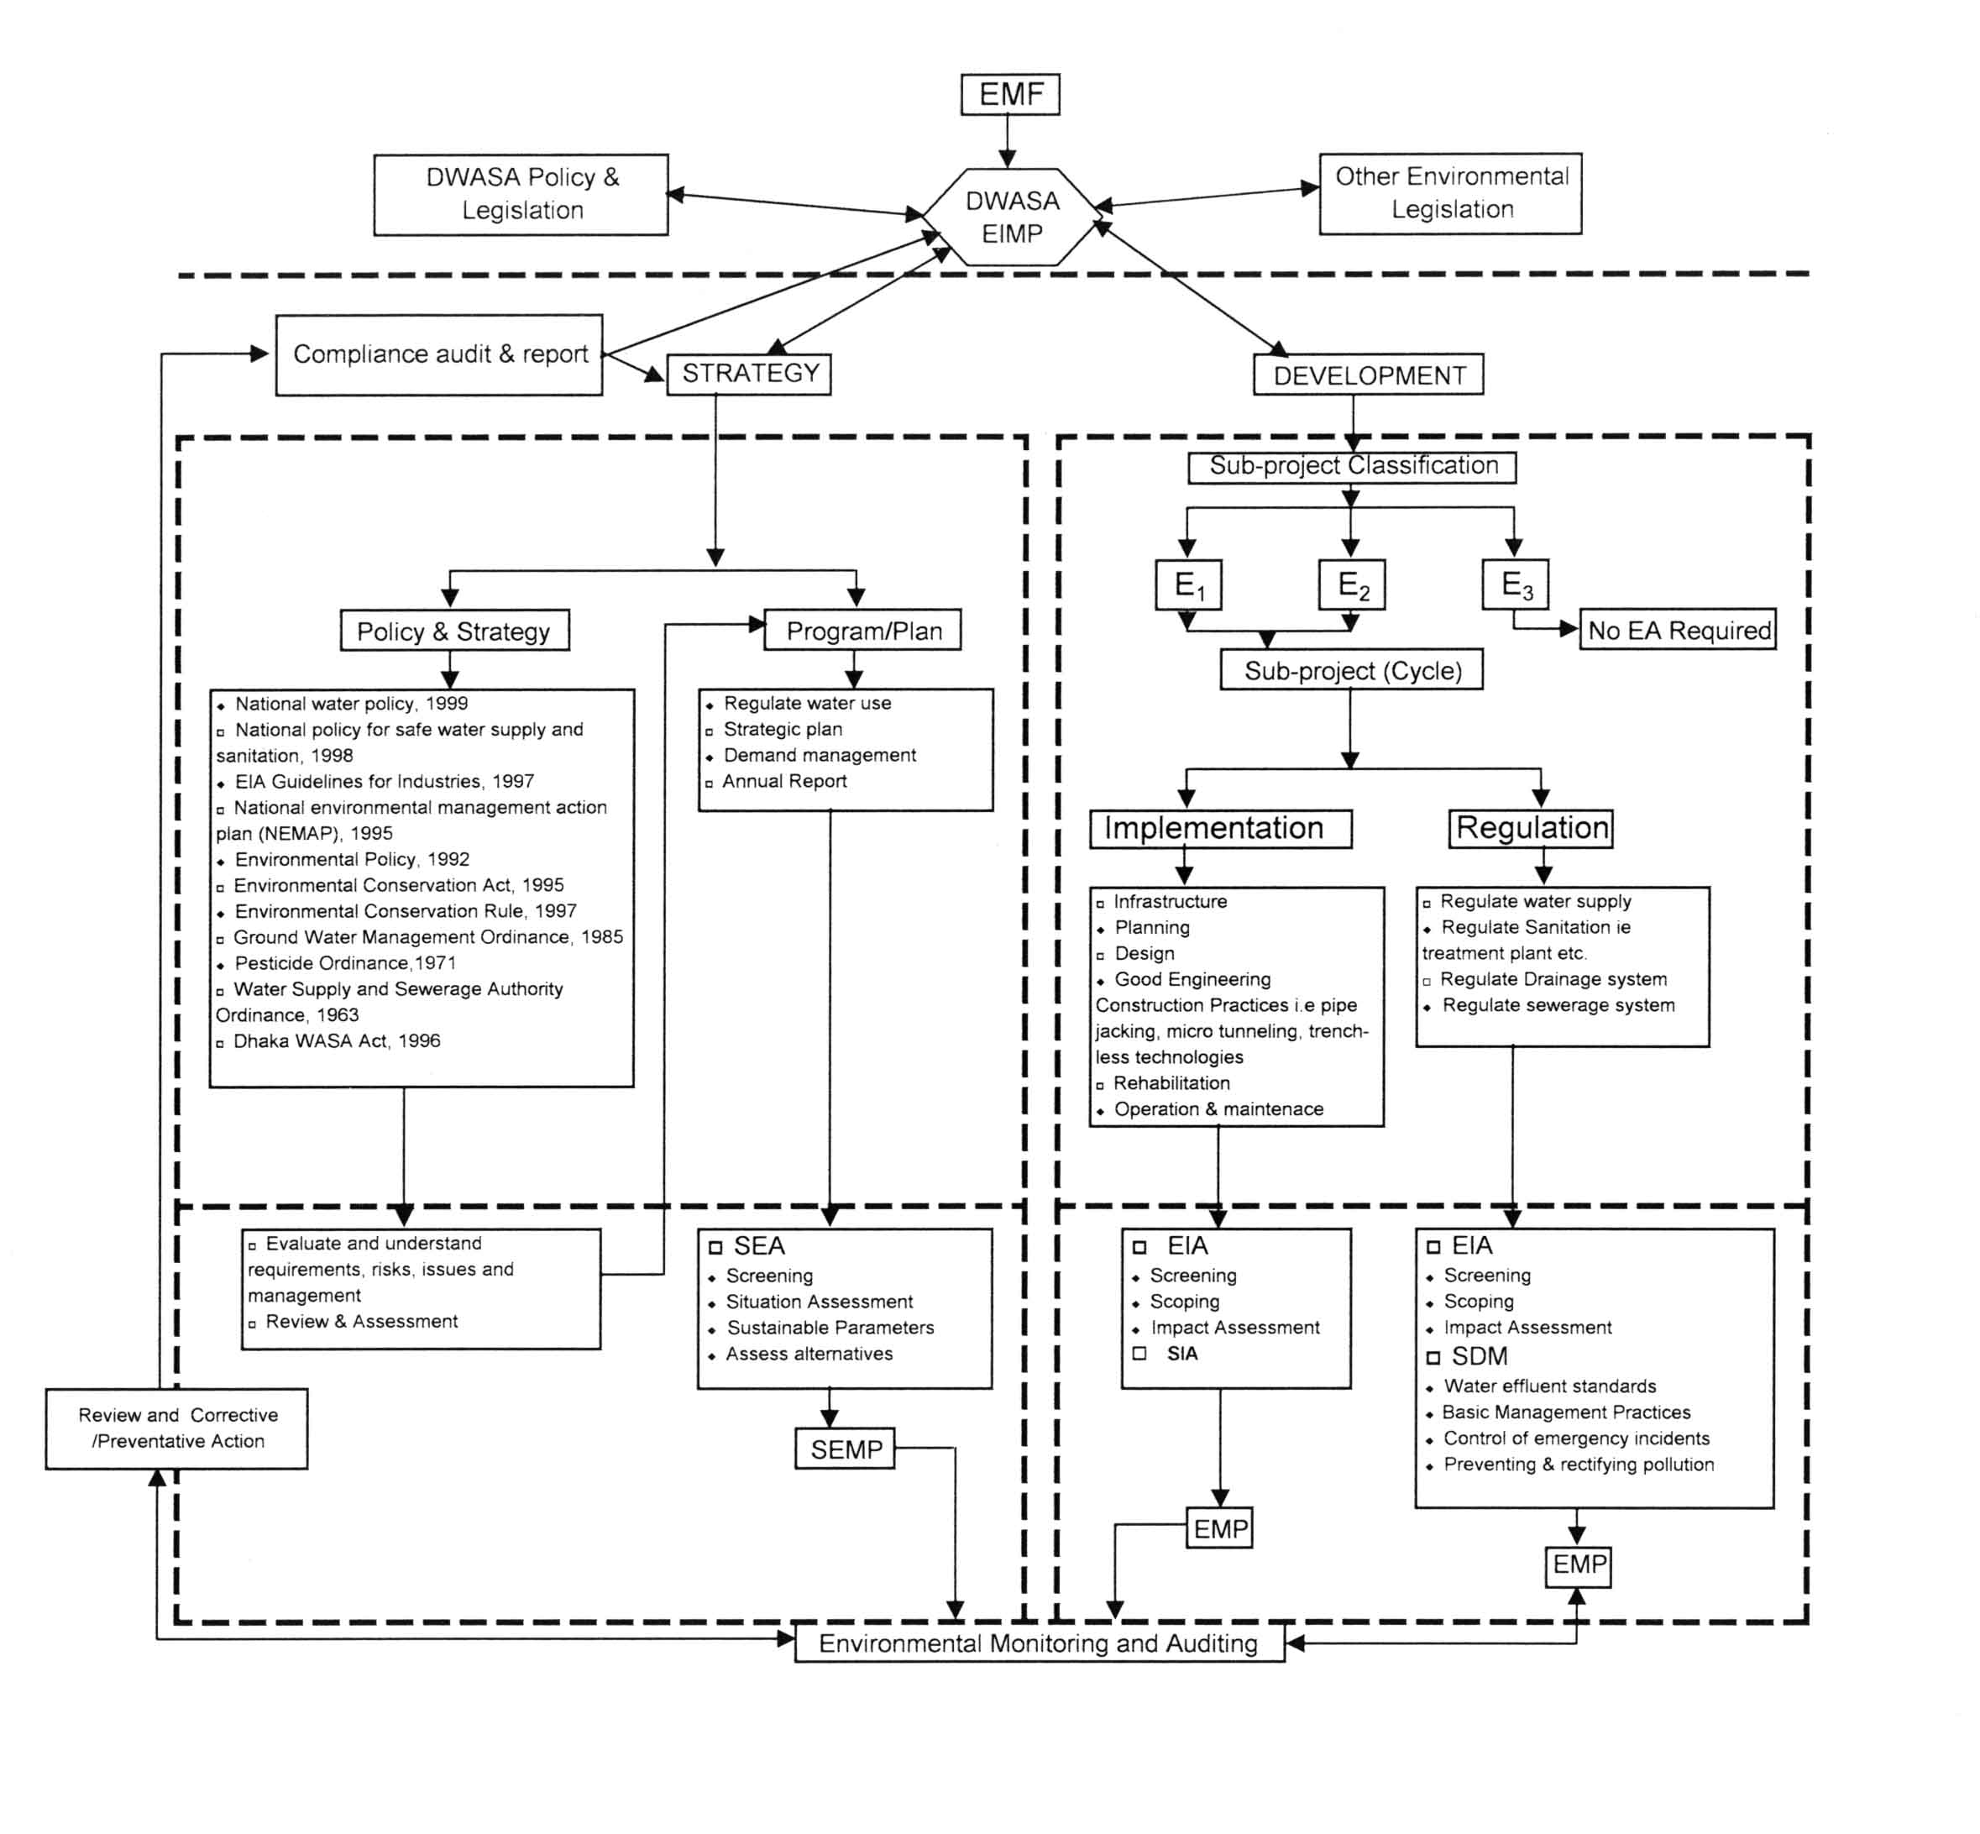

Identification of a Broad Goal

Defining the problem and identification of policy is likely to initiate Policy Formulation. Defining the problem and the identification of policy issues occurs in a number of ways. For example, compliance of actions recommended by the international donor agency or a change in Government can stimulate certain issues to be placed on the political agenda. Therefore, it does not follow a pre-determined process, but occurs in response to certain issues raised and needs expressed in several different arenas. The National Water Policy will define the agenda for ongoing policy formulation and review.

Policy Development

In Bangladesh the Department of Environment (DoE) under the Ministry of Environment and Forest shall play the key role for formulation of policies, rules and regulations with respect to the environmental issues. However an Inter-ministerial Steering Committee (ISC) may typically be established to oversee the policy formulation process. The advantage of the ISC is to ensure that the policy process is not dominated by a single individual or group. The DoE should play a vital role in the policy formulation Steering Committee and be requested to hold the mandate of environmental management plan (EMP).

Following the establishment of the ISC a process of technical and specialist research is undertaken with the intent to producing a working document for distribution to stakeholders. Environmental issues should be incorporated into the Specialist’s TOR to ensure that they are appropriately considered. To enable the incorporation of environmental management principles into the technical phase of policy formulation, a number of key questions have to be developed. The aims of these questions are to initiate environmental consideration and not to prohibit precise answers. Therefore, it is anticipated that the responses are likely to be quantitative rather than qualitative. The questionnaire needs to be further refinement and more closely align them and tested with the meaning of sustainability in a particular context. The questionnaire may include but not limited to the following :

- Does the National Water Policy address the inter-relationships and deficiencies of the various components of the water resources e.g. peripheral rivers, surface & groundwater?
- Does the policy address the inter-relationships of water quality and quantity?
- Does the policy address the impacts of human activities on ecological integrity?
- Does the policy allow for quantification of the desired ecological state and resultant availability of the resources?
- Does the policy require effective monitoring and reporting?
- How does the policy ensure that future generations have equal access to water resources as of current generations?
- How can provision be made for the assessment of positive and negative environmental impacts?
- How can the policy ensure equal access to the benefits of resource use amongst the social and disadvantaged group?
- How can the policy provide for the establishment of ecological limits?
- How can the policy provide for the identification and assessment of positive and negative environmental impacts of resource use on the natural environment?
- How can the policy address potential trade-offs between ecological integrity and other sustainable development objectives?
- How can the policy allow or disallow for the sustainability between alternative forms of investment?
- How can the policy support participatory decision-making process?
- How can the decision-making structures be clearly outlined?
- How can the roles and responsibilities of various stakeholders in the decision-making process be clarified?
- How can provision be made for information sharing and training of various social groups to allow them to participate effectively in decision-making?
- Are the participatory structures established appropriate to the needs of disadvantaged groups e.g. women and youth?
- How can the policy promote employment generation?
- How can the policy promote local economic development activities?
- How can the policy promote the satisfaction of basic human rights?
- How can the policy address potential trade-offs between economic welfare and other sustainable development objectives?
- How can the policy address the costs of increasing economic welfare on social and ecological environment?
- How can the policy ensure economic development on social and economic systems and to mitigate the negative environmental impacts on these systems?

These questions are by no means comprehensive and should be refined as additional knowledge of the policy process and environmental assessment within it is gained. Furthermore the questions should be refined as and when used to evaluate the environmental performance of policies. The environmental screening should be completed prior to distributing the policy for public scrutiny. The environmental issues should be incorporated into any discussion document, Green or White paper that is developed. It is recommended that the environmental screening should be included as an Appendix to the documents that are distributed.

Implementation of Policy
This involves the identification of appropriate measures or instruments for the implementation of the policy. If environmental issues have been included through the policy formulation stage, the requirement for further environmental “intervention” is unnecessary. In the case of environmentally related policies, however, appropriate environmental management tools should be identified and incorporated into the policy implementation process.

Monitoring and Review

The environmental management plan (EMP) is included within the EMF, the objectives of which are to outline DWASA institutional requirements, management, and monitoring measures that will be undertaken to ensure that environmental values are protected and enhanced through mitigation measures and these are monitored and reported in an efficient and effective manner.

Monthly report on the project performance management system (PPMS) should be submitted to the Project Implementation Unit (PIU) during implementation of project monitoring activities. The results will be used in a feedback loop to allow the PIU, project steering committee (PSC), and contractor to modify project implementation activities as and when required. A quarterly report of PPMS on monitoring activities will be prepared, submitted to the PIU and made available for public viewing through the community liaison office or respective MODS Zones of DWASA (refer to Figure 1) or through DWASA website.

Table 15 : Monitoring Review Schedule

Activity | Year 1 | Year 2 | Year 3 | Year…. | Year 10
Mitigation Measures
Monitoring and Review / Reporting
Training Arrangement
Technical Assistance (if required)

Undertaking Development Projects
DWASA is currently responsible for undertaking all development projects especially all identified 10(ten) sub-projects funded by the World Bank. The development plans and programs is a key component for DWASA. Specific functions in this regard include but not limited to the following requirements :

- Facilitate and co-ordinate catchments management, surface water management, groundwater development and institutional development;
- Promote equitable allocation, beneficial and sustainable utilization of groundwater as well as surface water resources;
- Promote integrated sustainable environmental protection zone and management of water quality of water resources;
- Management of strategic water resources development plans;
- Restricts groundwater extraction through private DTW.

Roles and responsibilities of EMF Process
There are number of potential role players in an EMF process, which includes :

- Proponent or executive agency of the project;
- Consultant who acts on behalf of the Proponent or executive agency;
- Interested and affected persons i.e. Project Affected Persons (PAP); and
- Competent authority i.e. The Department of Environment (DoE) is the Competent Authority for all Environmental related decision and DWASA is the Proponent or executive agency.

Upon completion of EIA by the Environmentalist or group of Consultants, it is the responsibility of the proponent of executive agency to ensure that the conditions of approvals are carried out properly and efficiently for both monitoring, mitigation and auditing.

Projects that have few or no environmental impacts are allowed to proceed without any additional environmental assessment studies. The screening process however does not exempt the project proponent from the requirements of the relevant procedures and policies.

Should the screening assessment indicate that the project have negative impact on the environment &/or additional information is required, the project moves to a scoping level in the process. If the project is considered to have limited environmental then the following stage of assessment will be project approval and the preparation of EIA follow-up procedures. If additional study is required, the environmental assessment will be required to follow the regulatory process and will be required to undertake screening.
It is the responsibility of the proponent to conduct regular internal audits of the environmental performance of the operation. The audit should be a systematic evaluation of the activities of the operation in relation to the specified criteria of the condition of approval. The auditing results should be transmitted to the competent authority for review and comments (if there be any). Including the auditing process should be compliance monitoring of the surrounding environment. The compliance monitoring should be the responsibility of the proponent and the results are transmitted to the competent authority. The competent authority may choose to undertake ad hoc monitoring to verify the compliance monitoring results. The auditing and monitoring results may be prepared in the form of an Environmental Performance Report, which should describe the extent to which the organization has complied with its environmental requirements. The aim of this report should be to provide honest information about the environmental performance.

Revision of EMF
The consultant recognize that the Environmental Rules, Policies and Regulations which are currently available in Bangladesh require improvement &/or modifications as per requirement of the EMF presented in this document. Once the Rules, Policies and Regulations are revised, then the present EMF should also be revised taking into consideration of the field of actual revisions. Similarly after testing in different sub-projects, the checklist forms may have to be revised in due course.

Conclusions and Recommendations

The Conclusions and Recommendations are as under :

- EMF sets out to ensure that DWASA and their Employees including the top Management are well aware of the environmental responsibilities in terms of environmental rules, regulations & policies,
- The gaps on various issues for EMF have been identified and remedial measures have been recommended. It is essential that these recommendations are implemented for making the EMF functional.
- EMF sets out a number of Environmental Management and Assessment Tools which should be considered when addressing the concerned parameters,
- The Checklist software has been designed in Excel, could be used as an Important tool for preliminary assessment of the environmental impact categories of any future projects of DWASA,
- The Environmental auditing should be done at certain intervals and revision of EMF may be attempted after testing all ongoing sub-projects financed by the World Bank (DS 1A to DS 10)
- The document should be made available for public consultation in DWASA and World Bank’s websites and all valuable comments are recorded properly to be incorporated during revision of the present EMF.

The “Project Implementation Manual” has been prepared and attached with this document in Annexure 2, which will be a useful tool for the implementation of the sub-projects (DS 1A to DS 10) and new projects to be undertaken by DWASA. The manual can be improved in due course after testing in order to suit their requirements and circulated to the concerned personnel who are associated and responsible for the implementation of the sub-project &/or new projects.

The “WSS Manual for Low Income Communities” has been prepared in Bangla and attached in Annexure – 3, which will be useful tool for the creation of public awareness campaign upon distribution to the inhabitants of slum & fringe area by engaging NGO. This manual may also be used by the NGO who are engaged for improvement of any urban slums or fringe areas for providing respective services to the low income communities with the financial assistance by other donor agencies.

GP- Good Practices
OP- Operational Policies
OD- Operational Directives
BP- Bank Procedures
Population 13 million (ToR DS-7); Design value 180 lpcd and therefore total Demand = 2340 mld (DWASA Strategy Study; Financial Forecast Report, January, 1998) and present water production = 1600 mld (MIS Report, March, 2007), therefore water shortage = 31%
Wastewater Engineering Vol 1, Fair, Geyer
ToR DS 2
Source: Sadler & Verheem (1996)
SEA is not mandatory under Environmental Legislation of Bangladesh

